

CSE370 : Database Systems
Project Report
Project Title : Student Job Portal

Group No : _05_, CSE370 Lab Section : _07_, Spring 2024
ID | Name | Contribution
21201114 | Tasnim Rahman | Super_ admin,customer_admin(login),company(add,edit,delete),job_offer (create,delete,edit),  Customers list(add,edit,delete),job searching.EER,Schema Diagram
21301601 | Tanveer Hasan | Frontend(blog.php, header.php, footer.php), EER
19101193 | Tanzeela Mariam | Frontend(available_jobs.php), Database(available_jobs), EER
22201674 | Sadia Hakim Mollik | Creative Part
22101623 | Arif Bin Islam | Sign up for (jobseeker, job provider), view cv, edit cv, applicants, approved candidates, available jobs, applied jobs, sign in

Table of Contents

Section  No | Content | Page No
1 | Introduction | 03
2 | Project Features | 04
3 | ER/EER Diagram | 04
4 | Schema Diagram | 04
5 | Frontend Development | 05
6 | Backend Development | 21
7 | Source Code Repository | 44
8 | Conclusion | 44
9 | References | 45

Introduction

Student Job Portal Database will be used to obtain and relay all necessary job opportunities from sourced organizations during the program duration.
In the area of academia and professional jobs, the relationship between the two is surging, and responding to this wave, the creation of digital platforms that offer tailored services is indispensable in facilitating effective transition from school life to work life. This emerged within the context of the employment of students and empowering them in relation to their searches and arrangement of the meaningful jobs with companies which provides them with effective personnel obtaining.
The project's pillars include the dual shortcomings that students and employers have to face in this essay writing market. By making use of a smart technological approach the Student Job Portal Database aims to abridge this search, offer more transparency, and facilitate mutually beneficial relations between all the stakeholders.
This project overview strives to verbally spell out the reasons and objectives of the Student Job Portal Database, pointing to the features, design precepts, and the anticipated outcome. We, thus, attempt to reveal the magnitude of the project through a complete examination of its architecture and functioning. The essay is intended to highlight this project's potential in terms of relationship between student employment, organizational growth, innovation culture, and integration.

Project Features

Job searching
Admin,Customer admin,Student login,Company login, Sign up
Company add,edit,delete
Job add edit,delete
Customer add,edit,delete
Job posting,
Feedback

EER Diagram
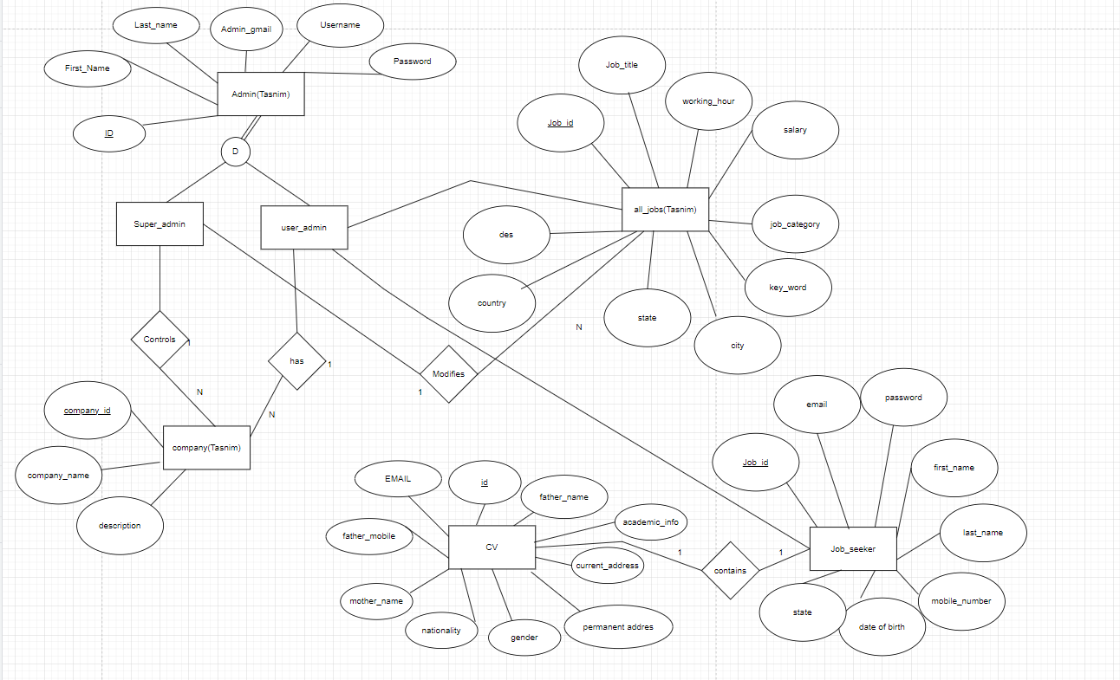
Schema Diagram

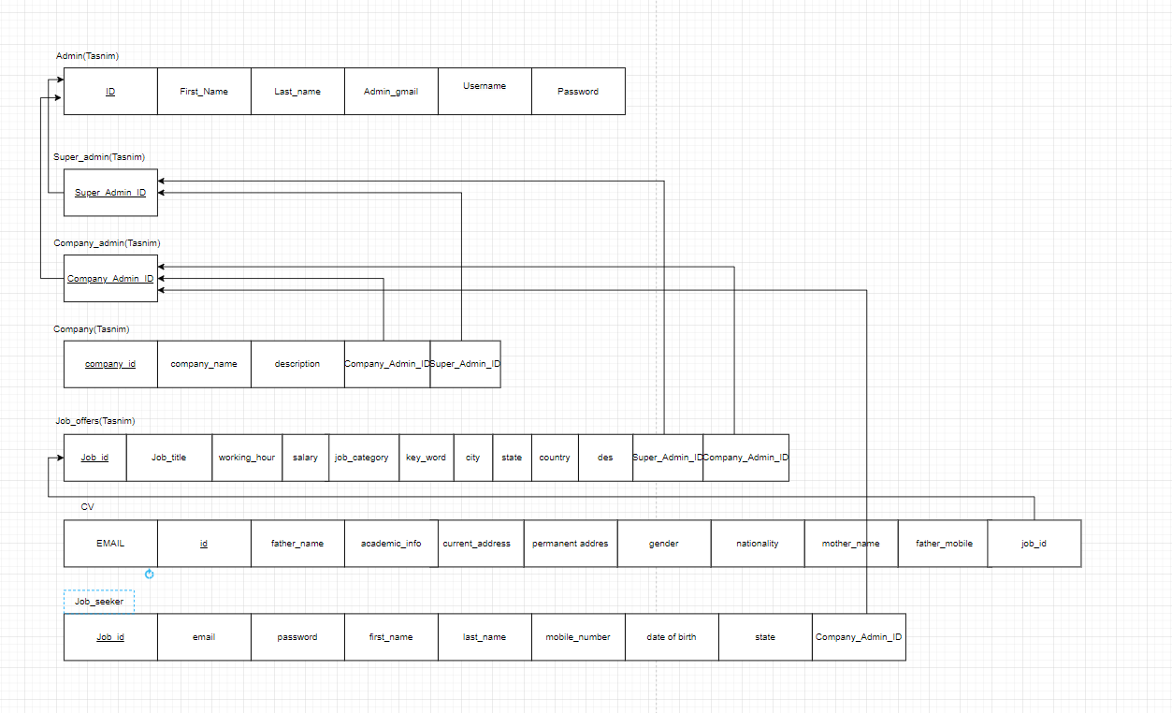

Frontend Development

Briefly discuss about Frontend Development and add Screenshots by mentioning Individual Contributions

Contribution of ID :21201114, Name : Tasnim Rahman:
● I have used CSS to style the HTML elements and create a visually appealing layout. This includes setting background images, defining fonts, colors, padding, margins, and borders to make the content visually appealing and readable.
● Created forms for user interaction , such as login form for admin, company admin and students. Dashboard for both types of admins, Company and job lists ,add and edit forms ,searching and showing jobs.

Job Searching:
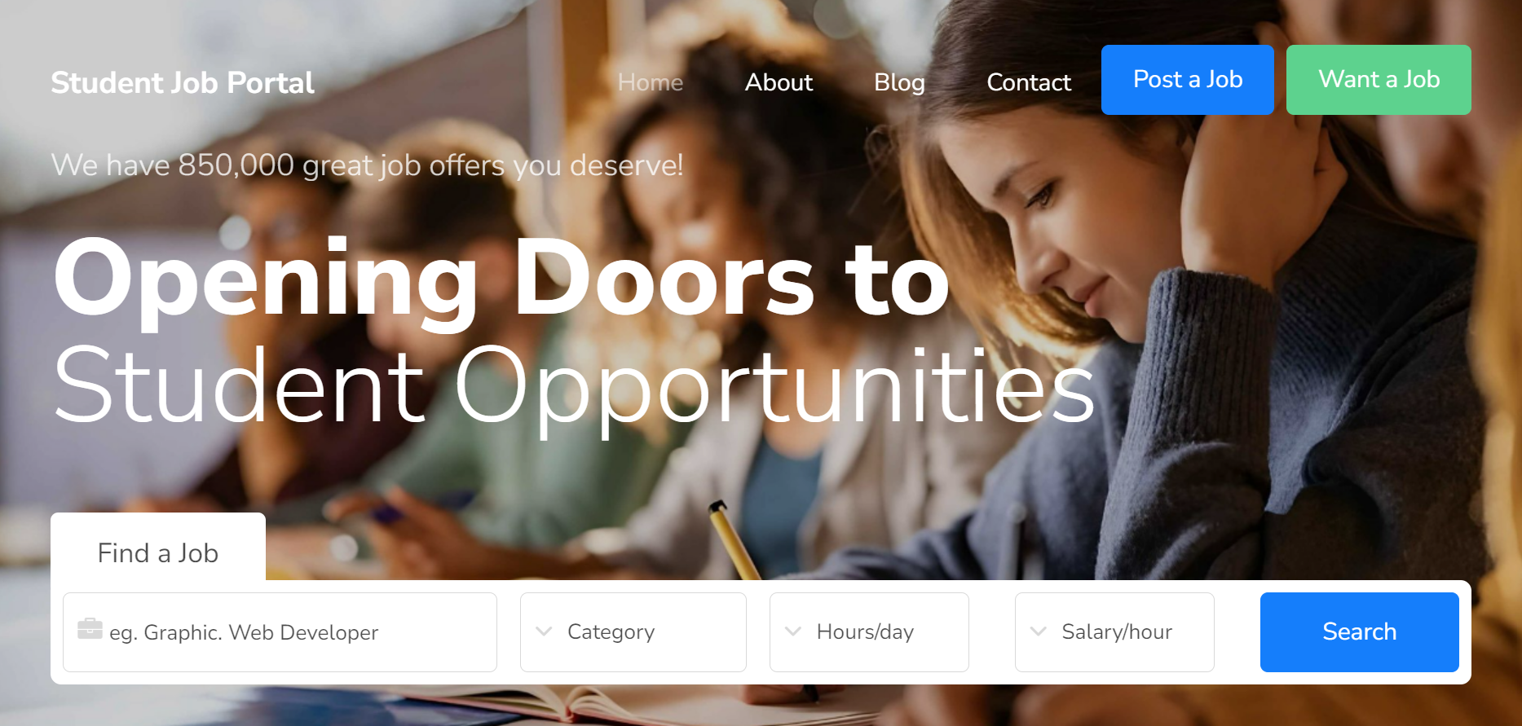

Super_admin:customer(add,edit,delete),job_create(add,edit,delete),company(edit,delete).
super_admin(login):
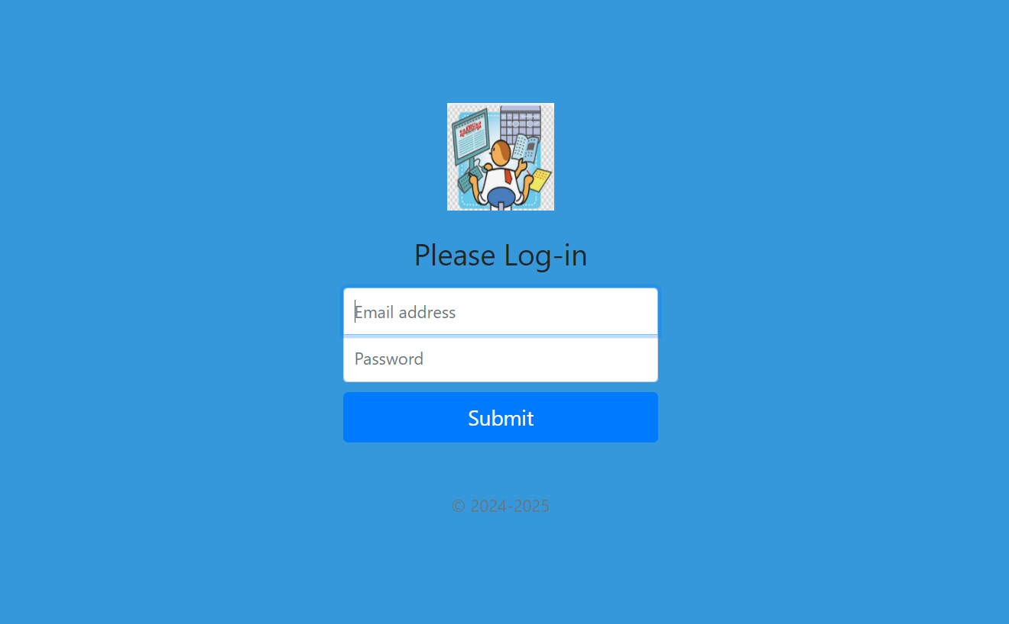
dashboard:
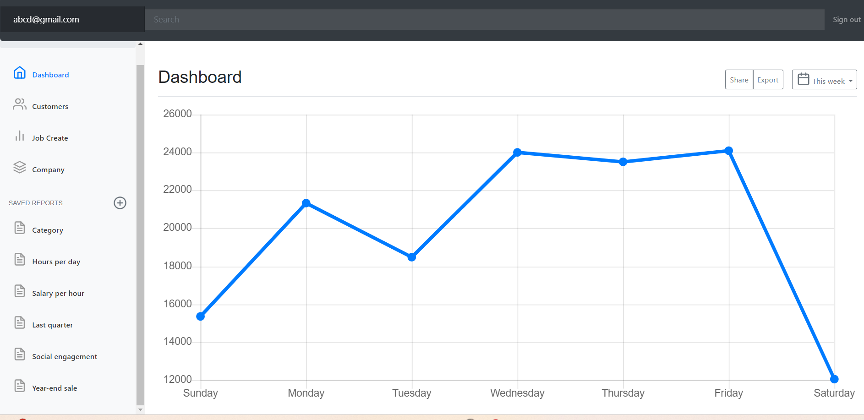

Customers list:( here AdminType1:Supe_admin,AdminType2:Customer_admin)
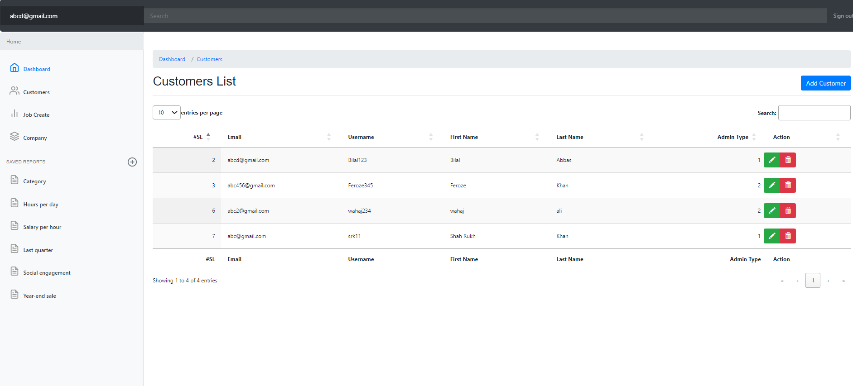customer-add and edit
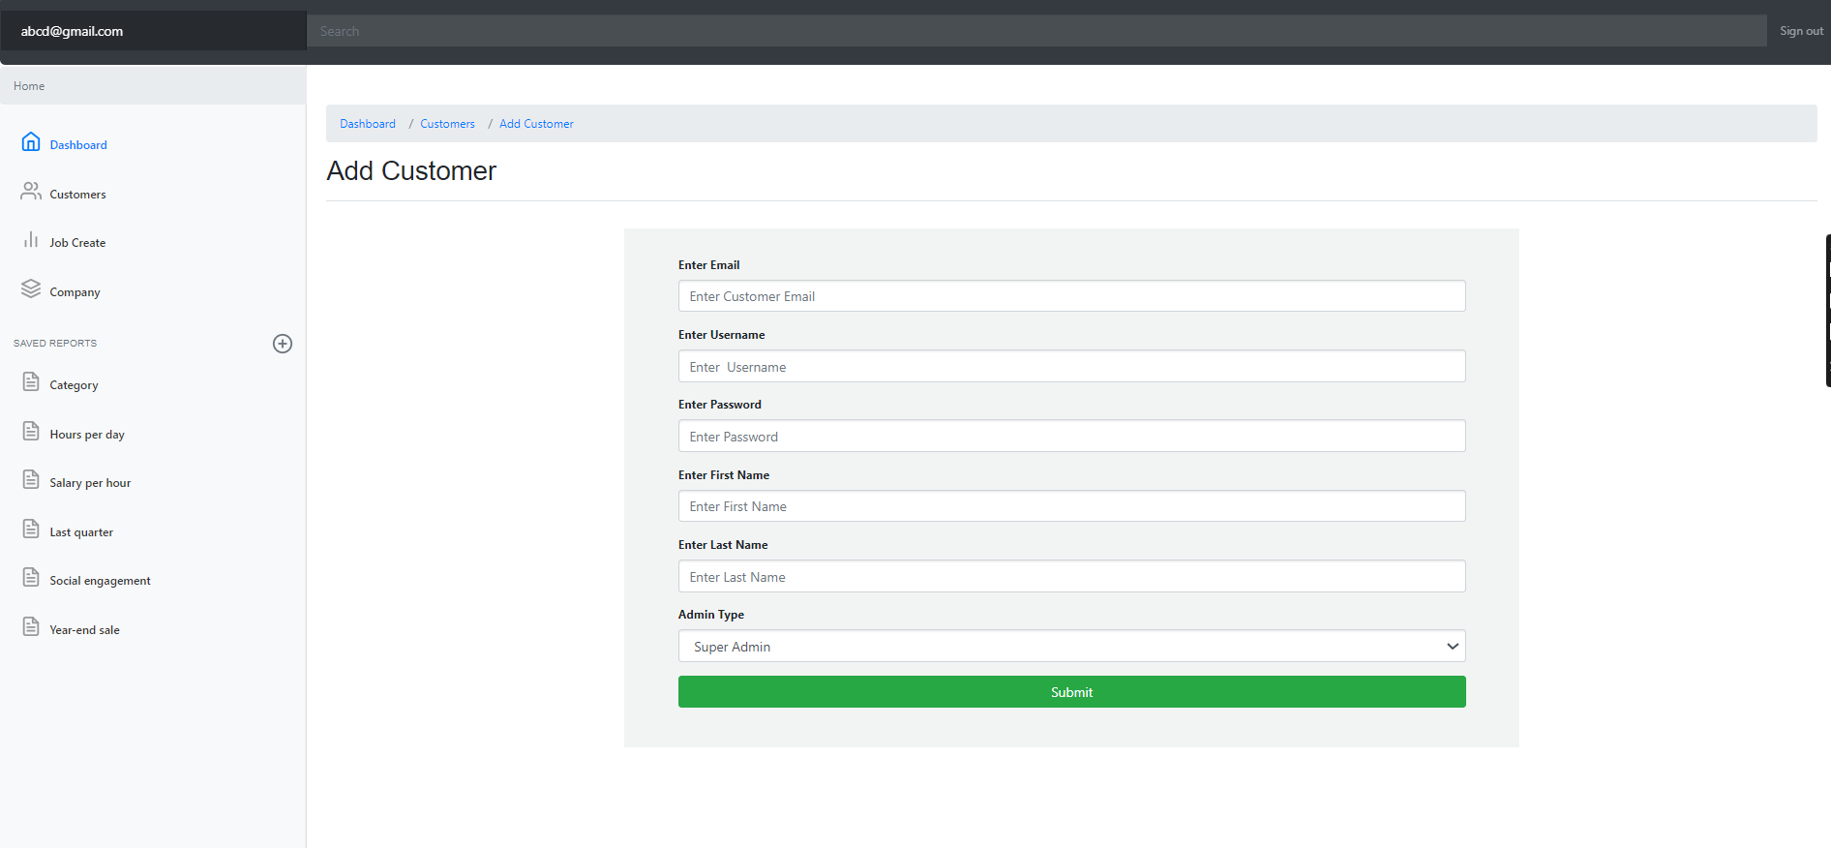
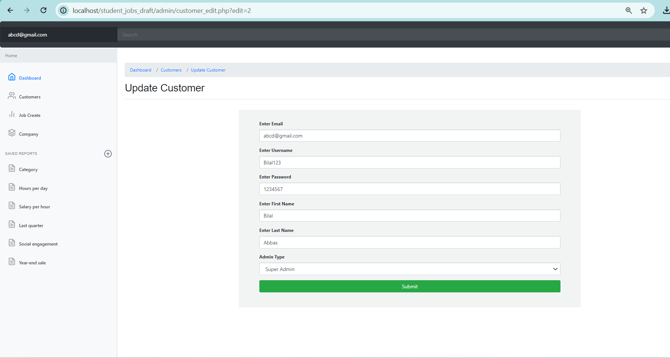
Job(list,add,edit,delete)
JobList:
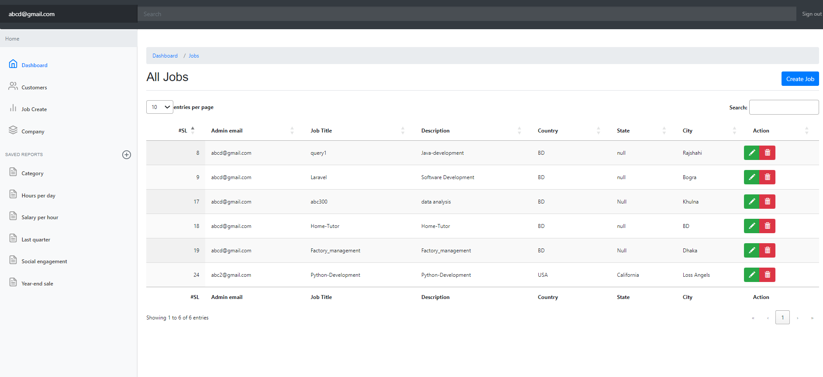
Add job:
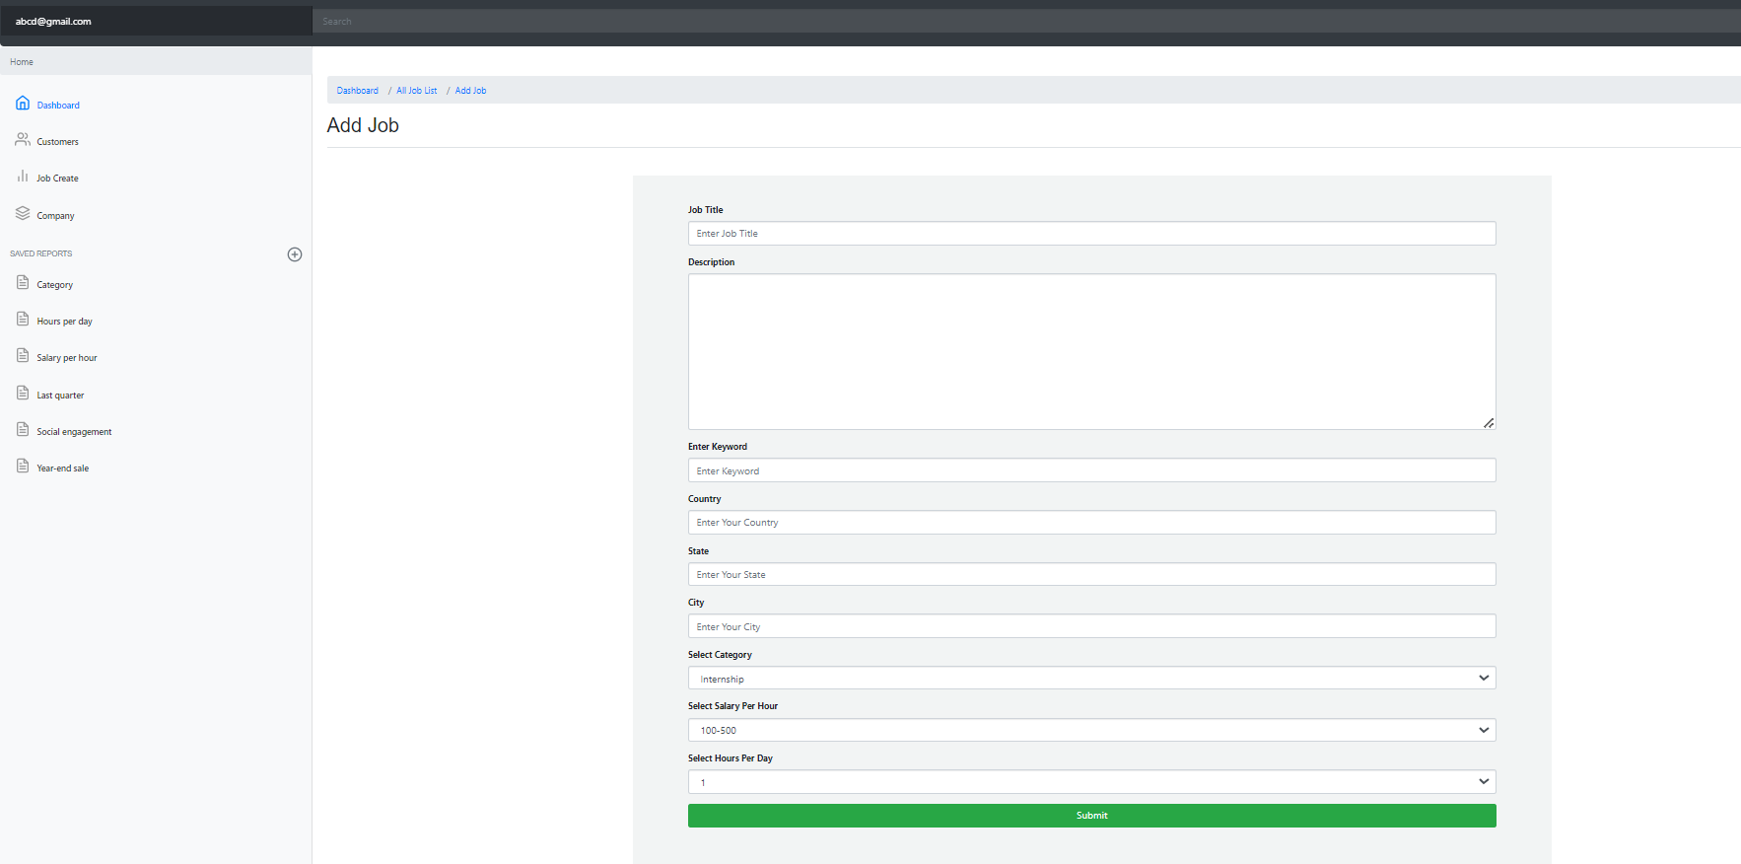
Edit job offer:
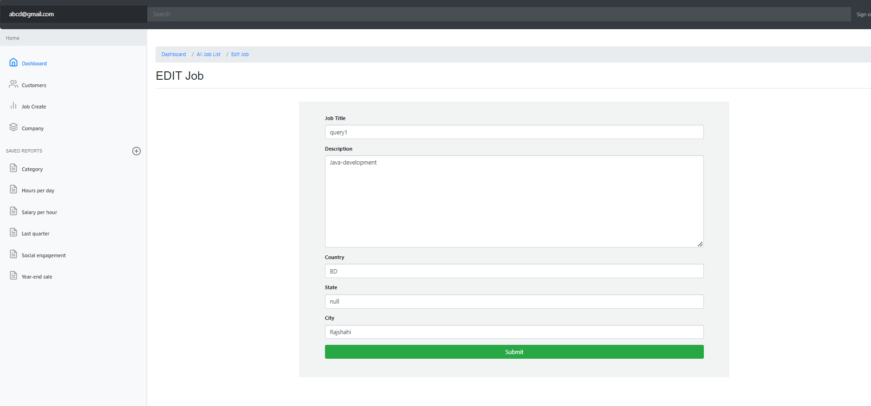
All available companies:
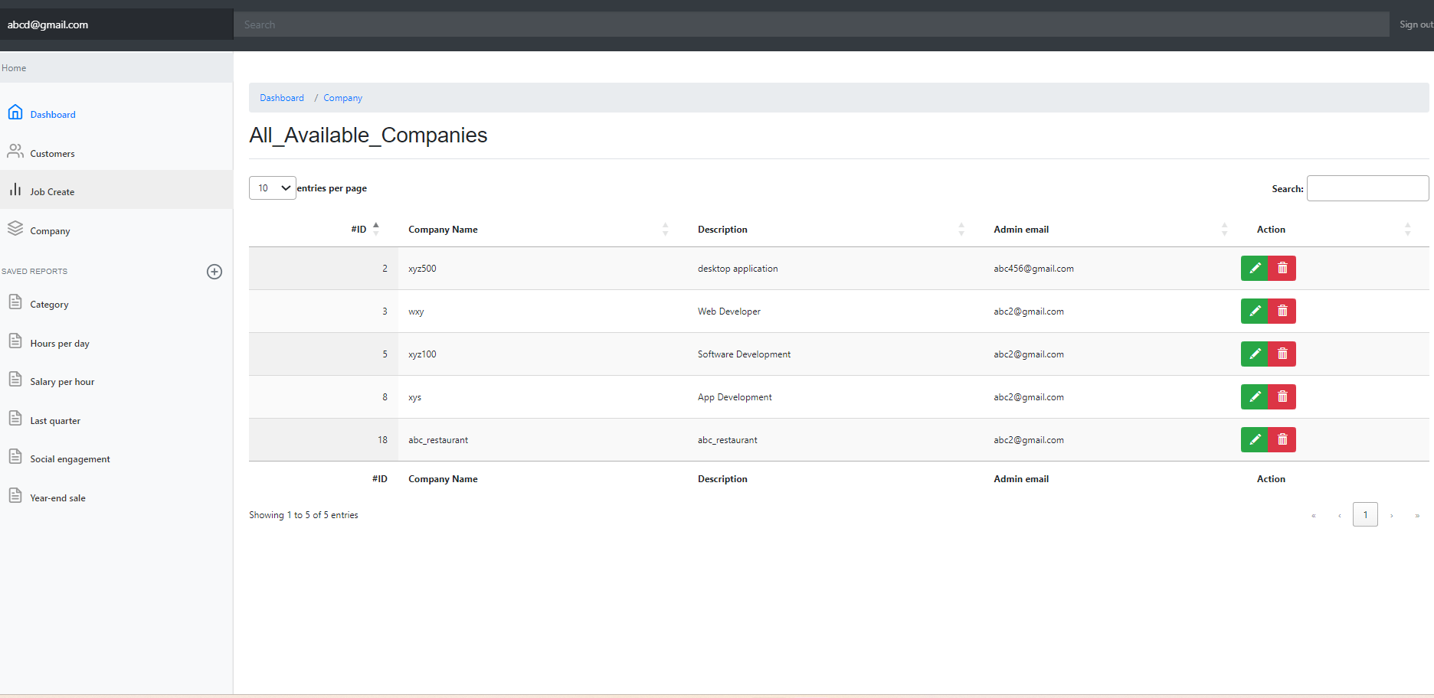
Super admin can update company according to their provider:
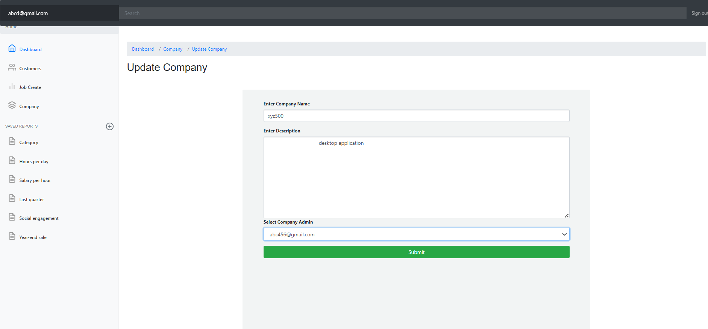Customer_admin: This entity is like brand ambassador which means he can be representative of many companies but we hire only one company admin or customer admin from each company:
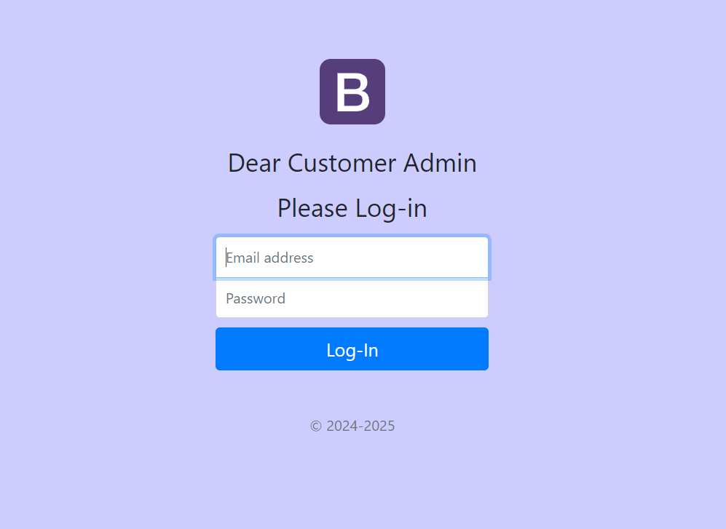
Customer admin dashboard: Here he has only job creation and company adding options.
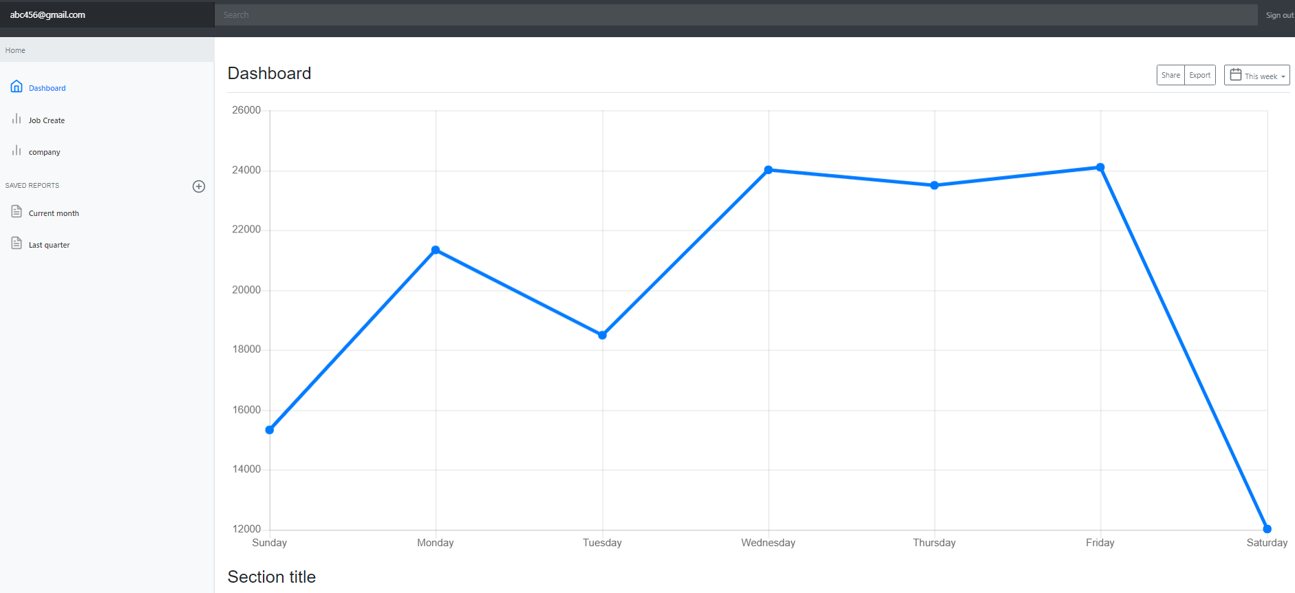

Customer Admin can see only his posted job offers and he can add, edit,delete from his list.
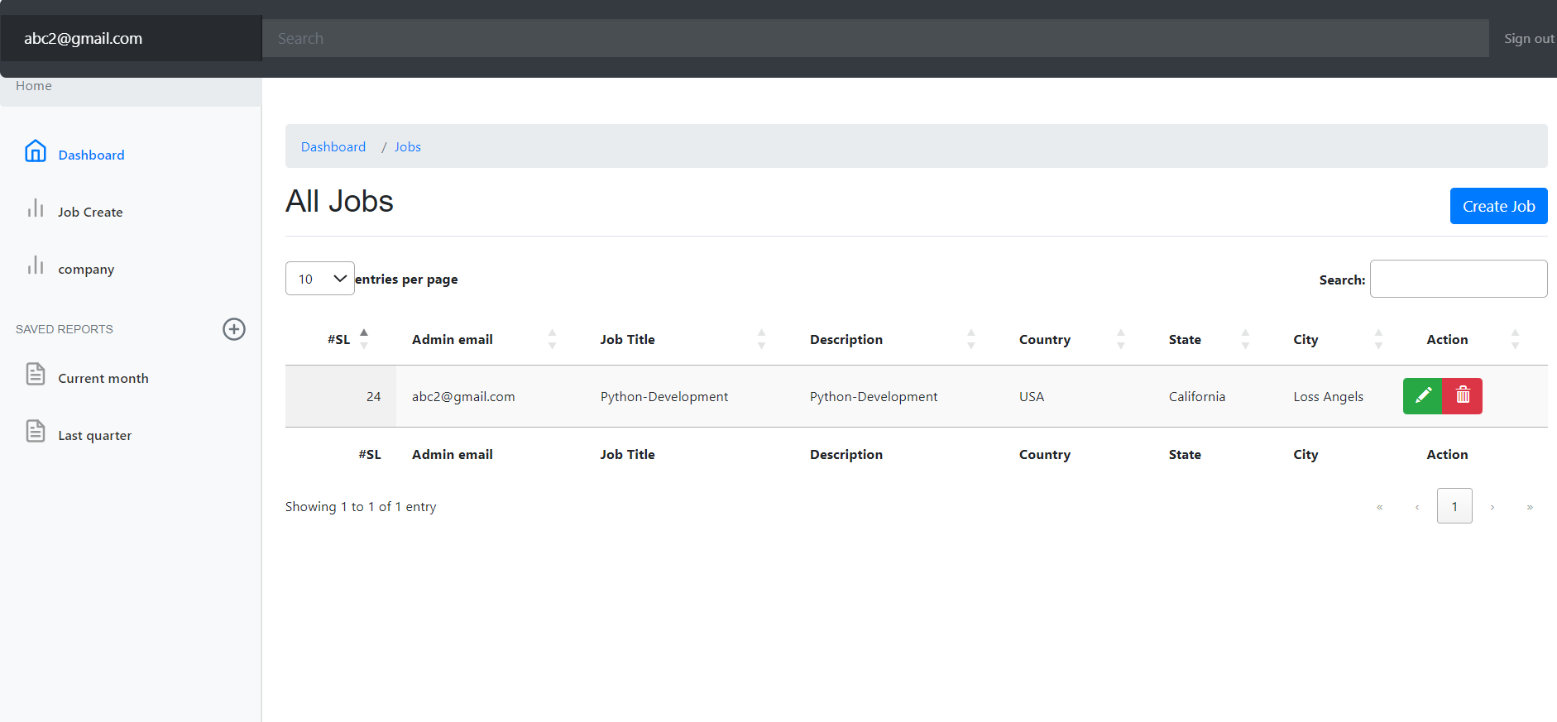
Add jobs: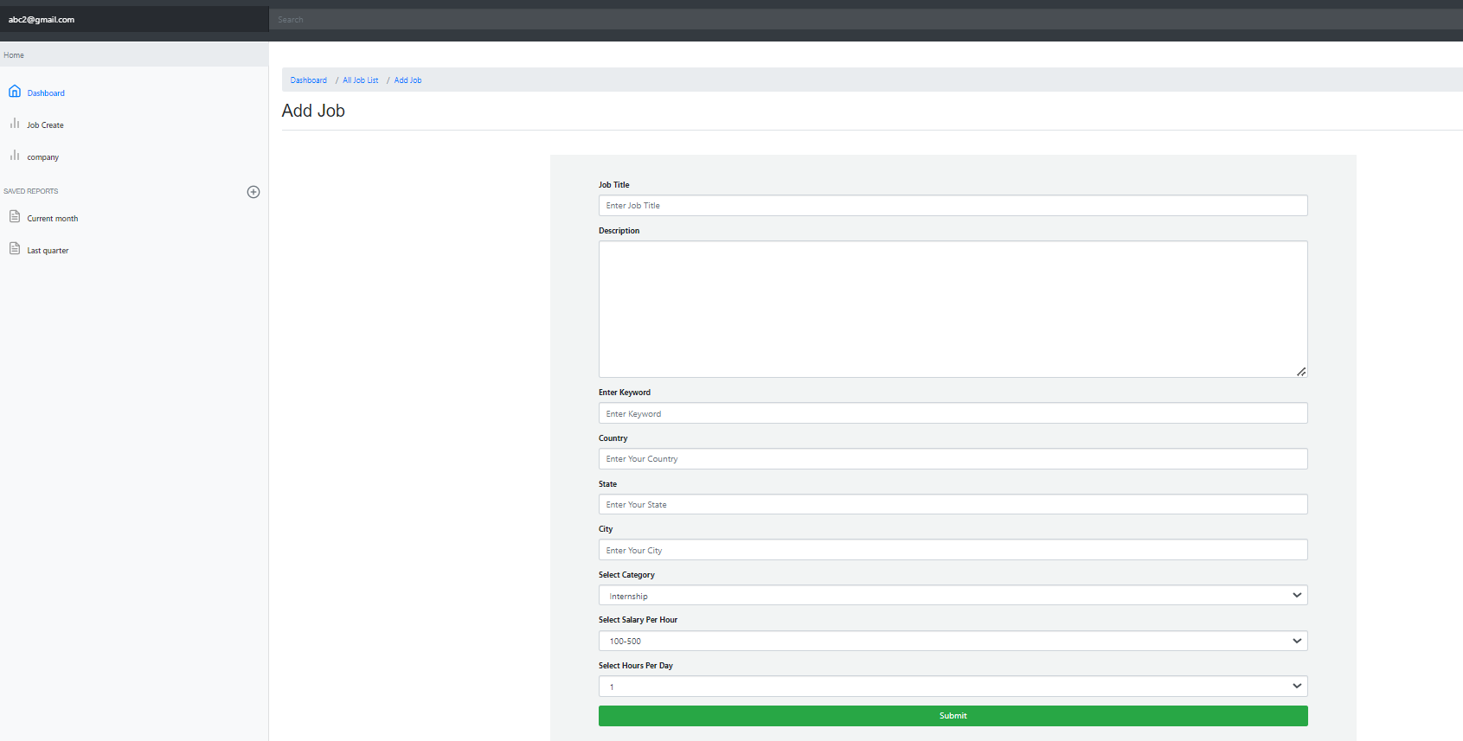
Edit_jobs:
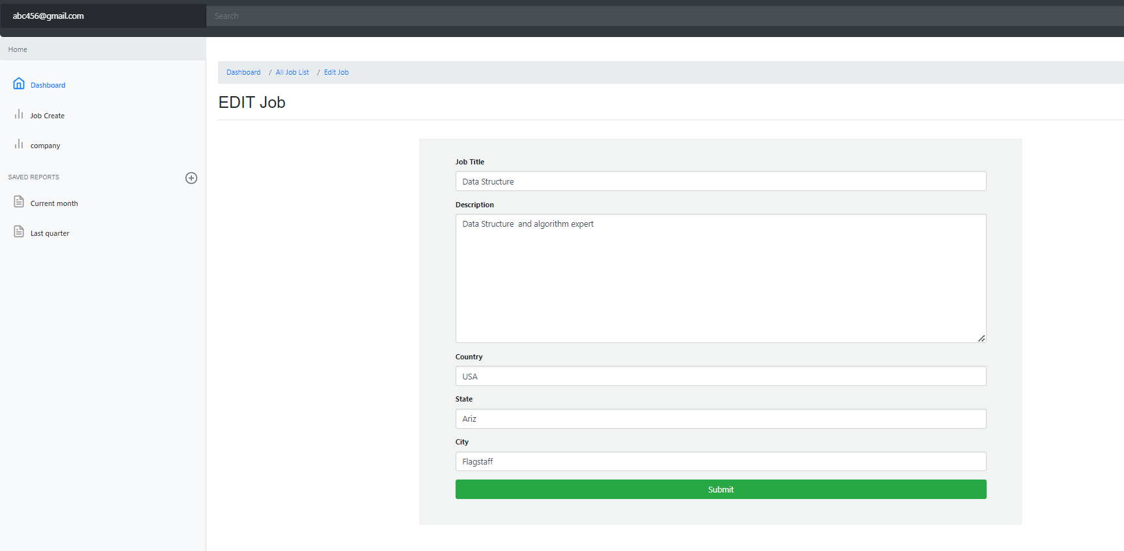10

Company-admin can only see his companies and can add ,edit ,delete to those :
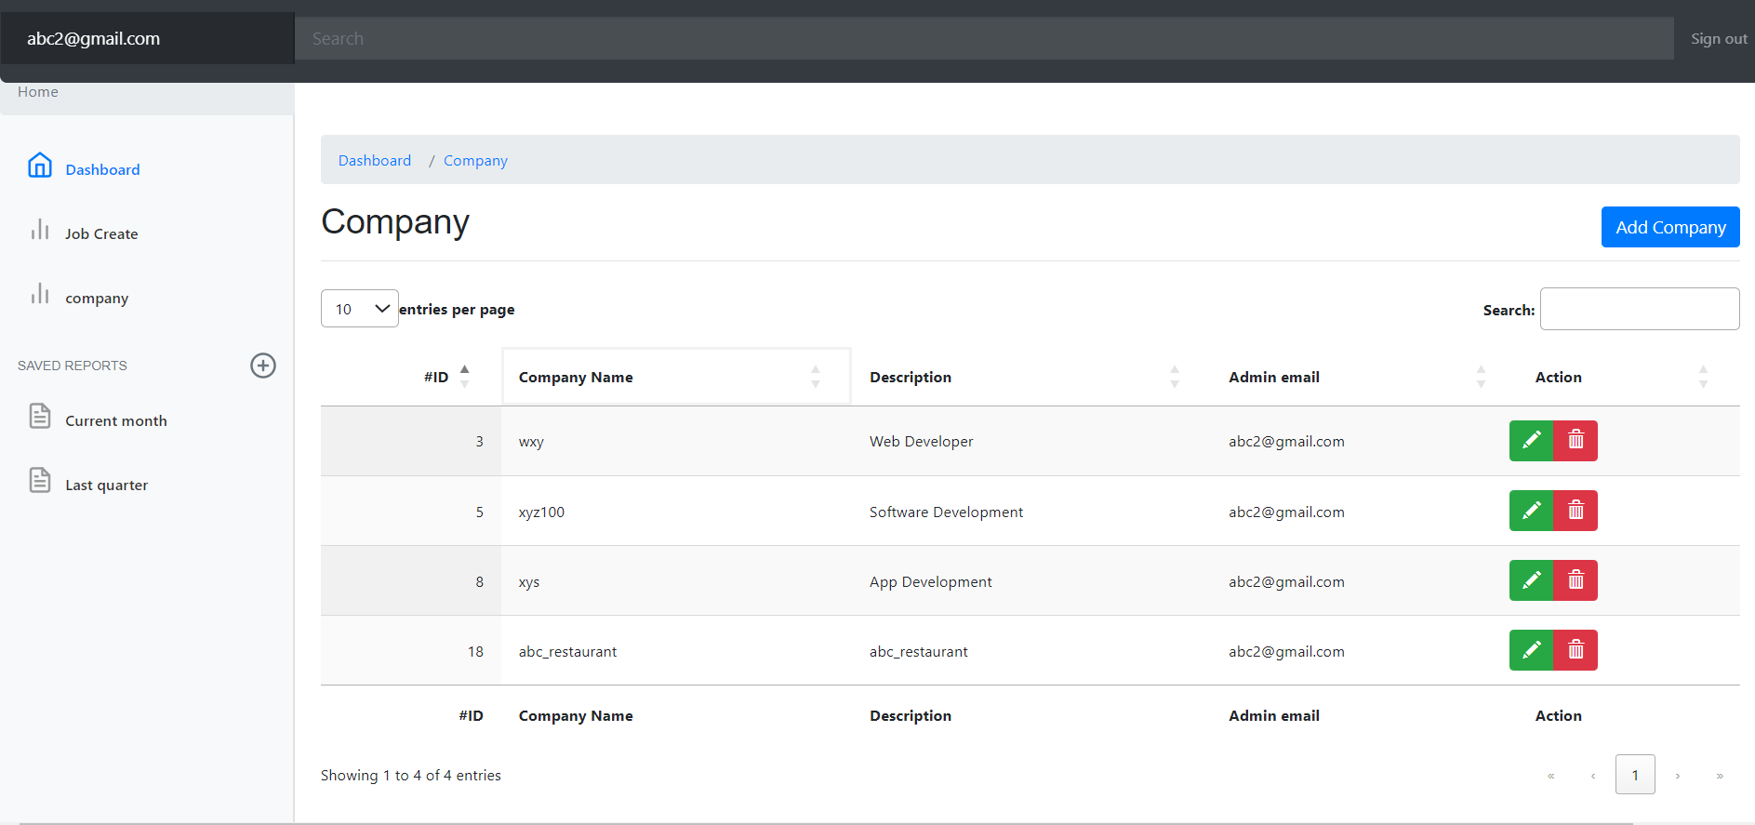
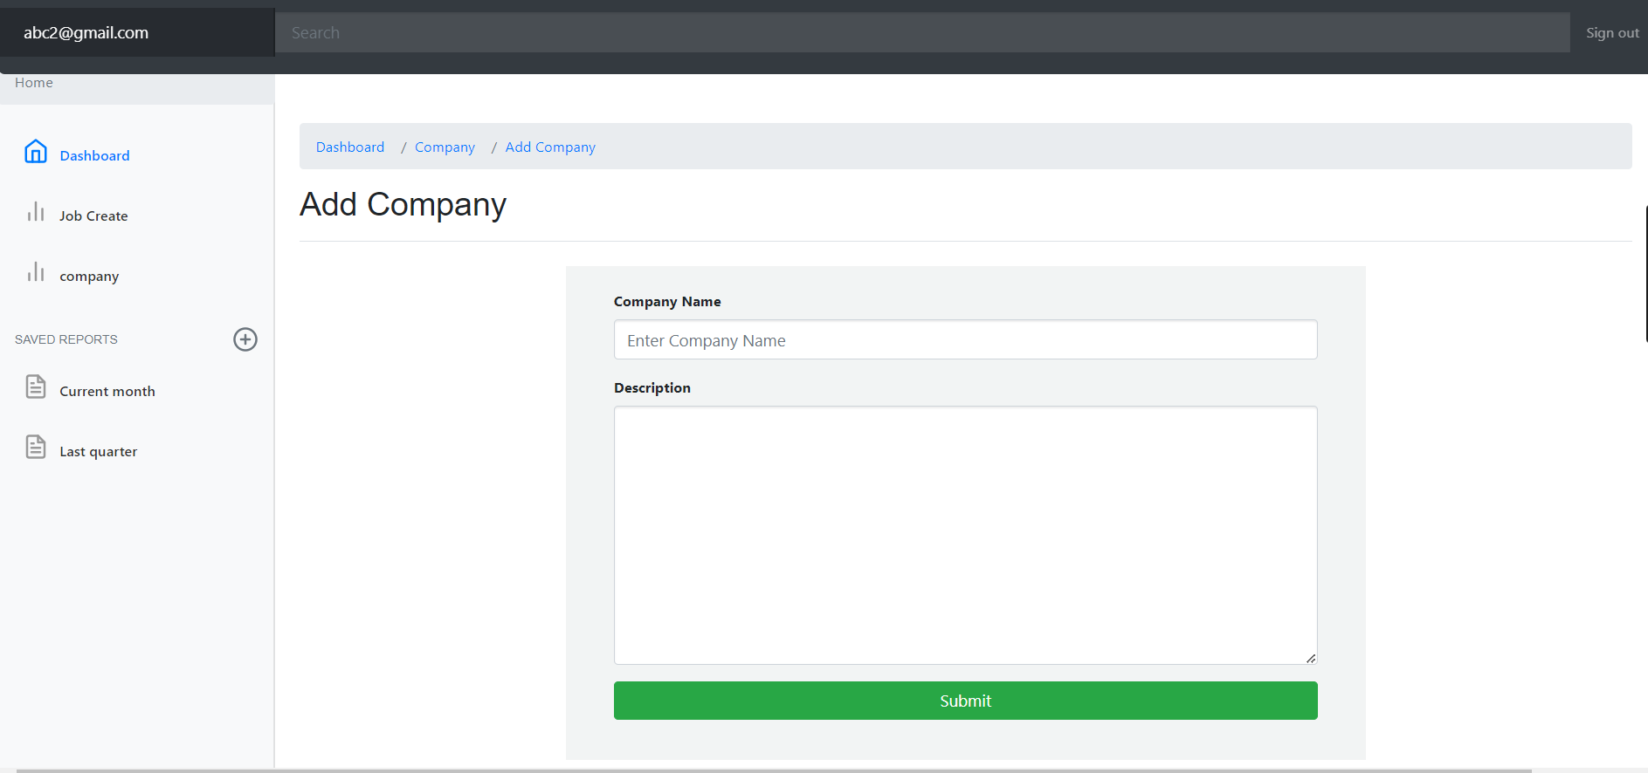
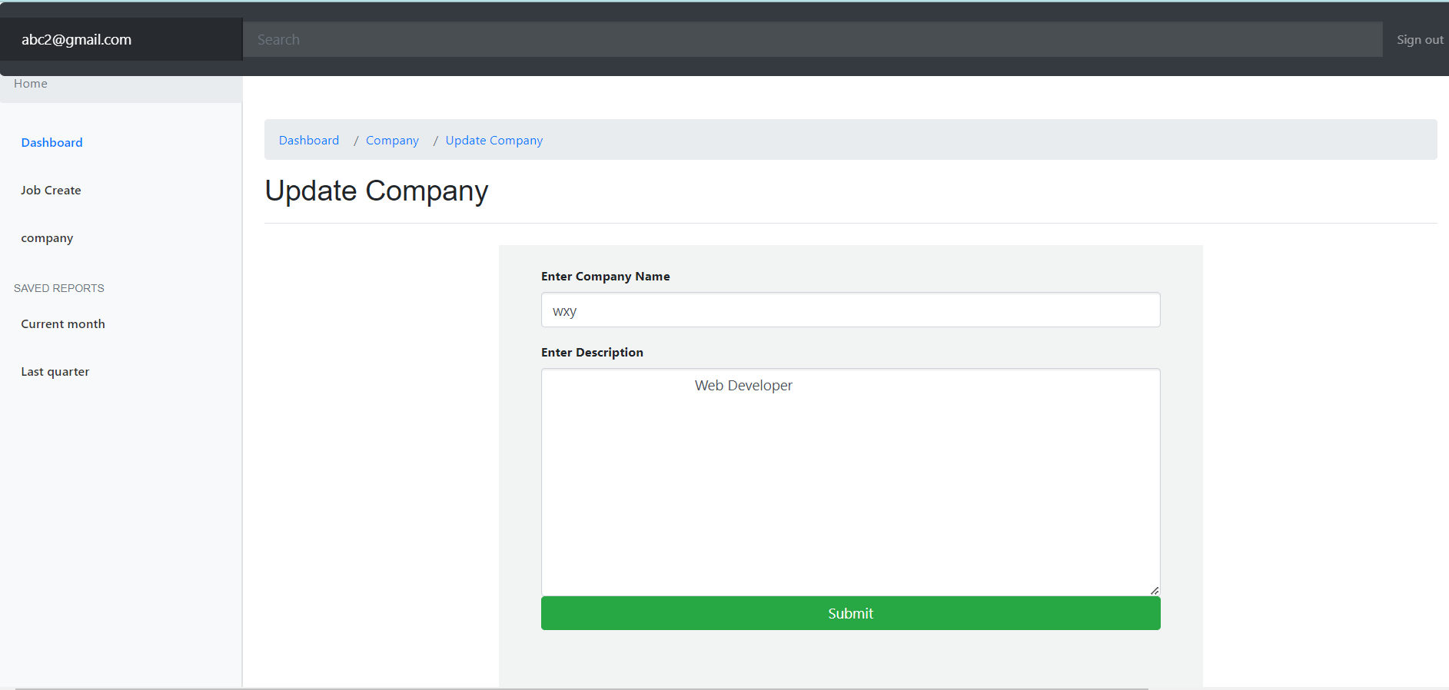

Contribution of ID :19101193, Name : Tanzeela Mariam

Frontend Development

I worked on the webpage ‘available_jobs’. I used the codes from bootstrap. At the same time the pages has been linked to the database. I was having an error with root.

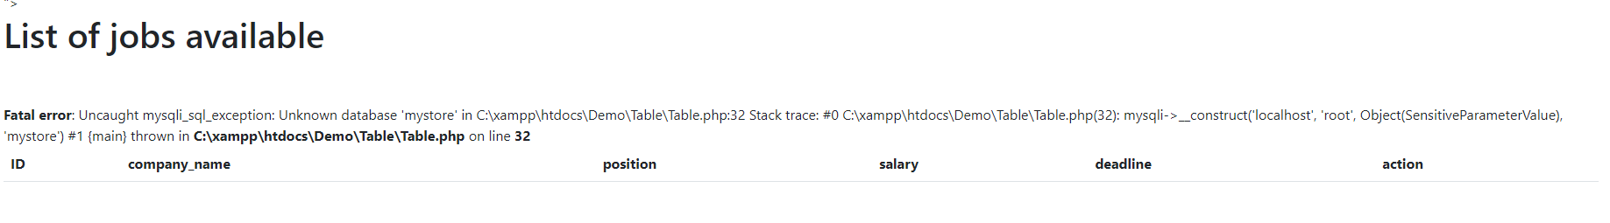
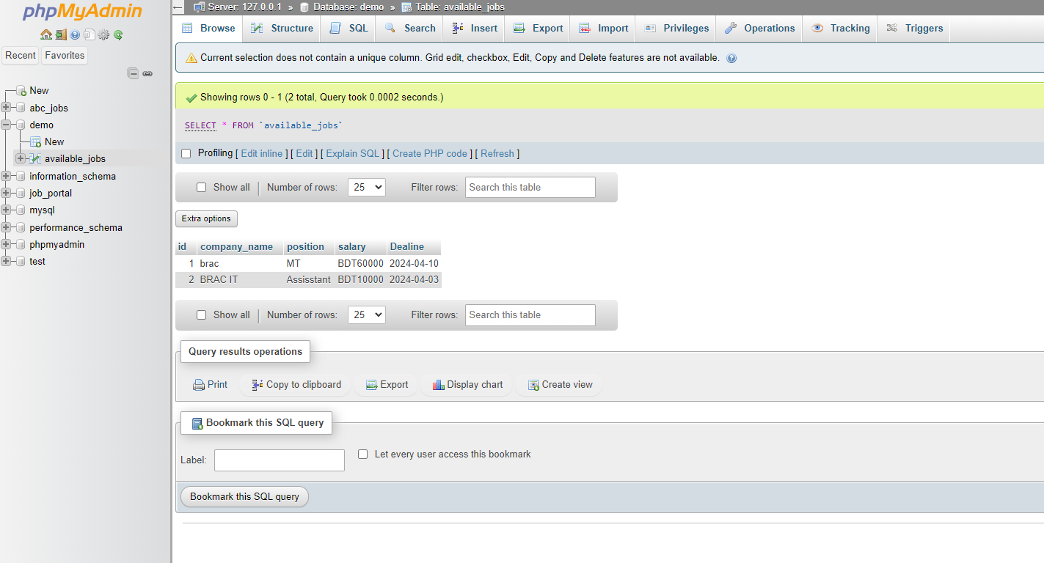
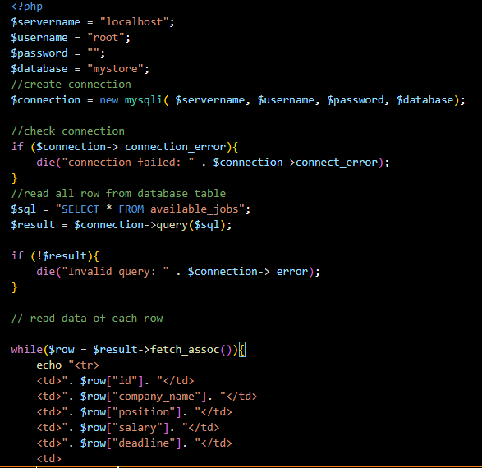

The code for connection is given above.
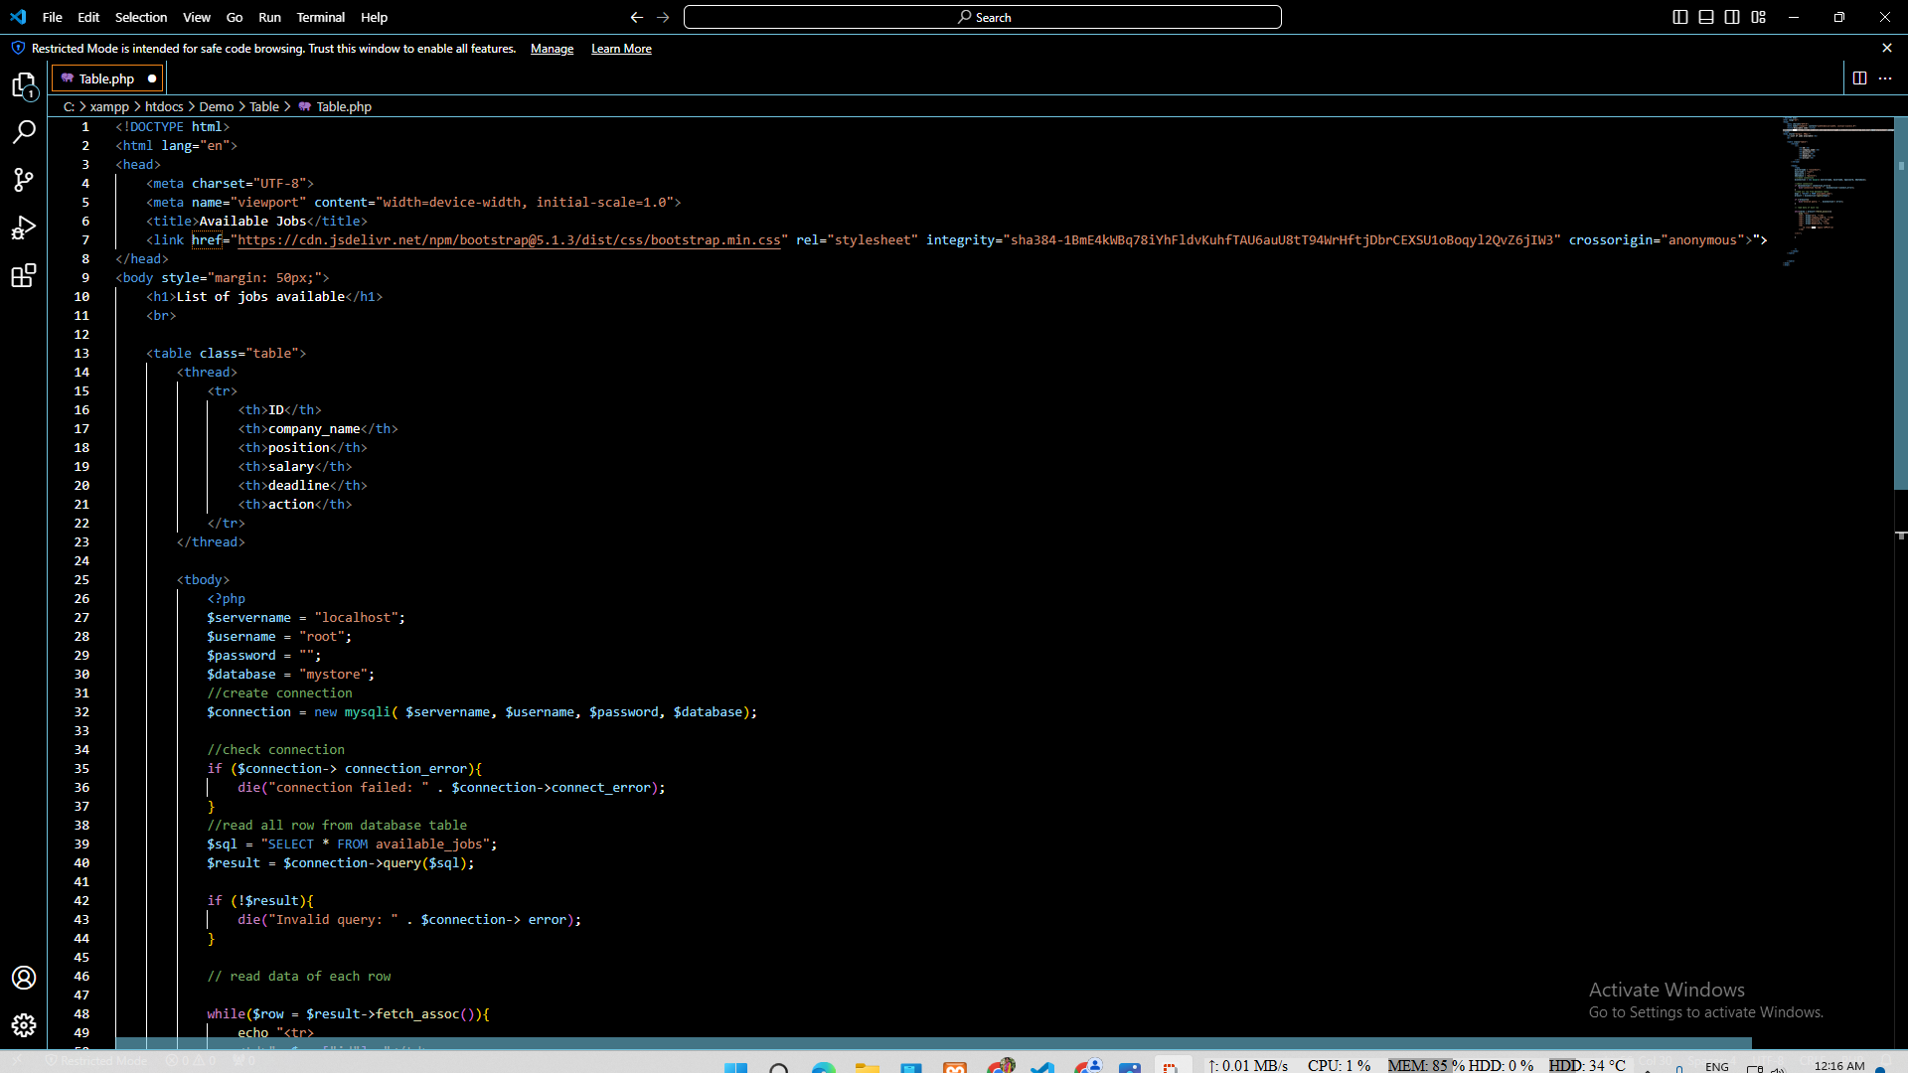
Code of the webpage: Available_jobs

Contribution of ID : 22101623, Name : Arif Bin Islam

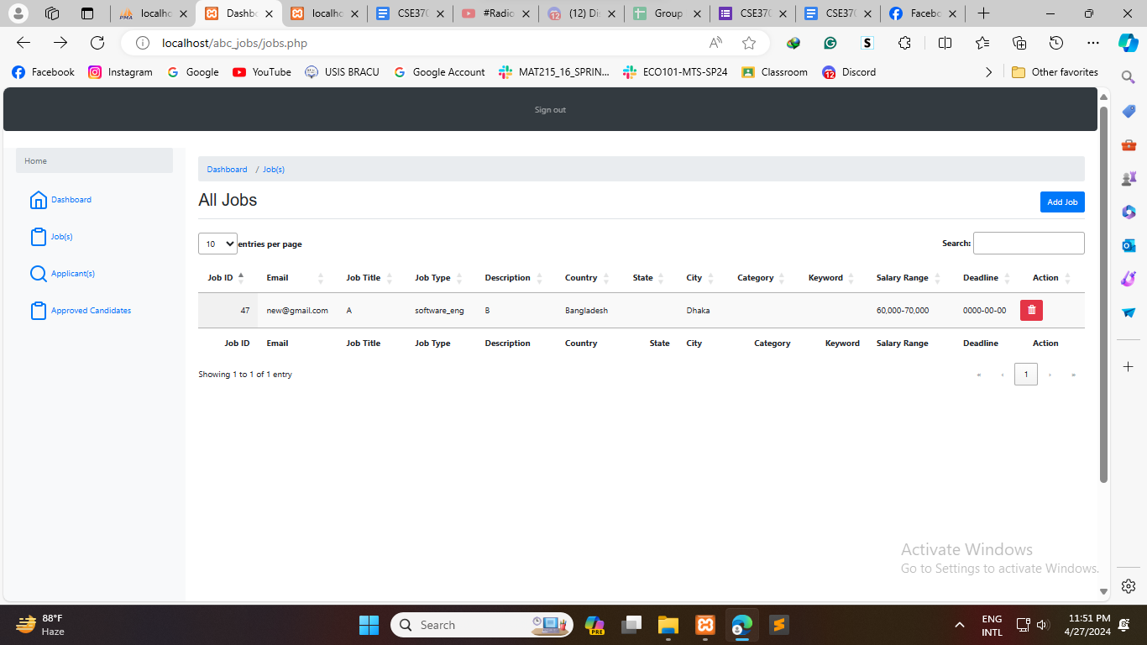
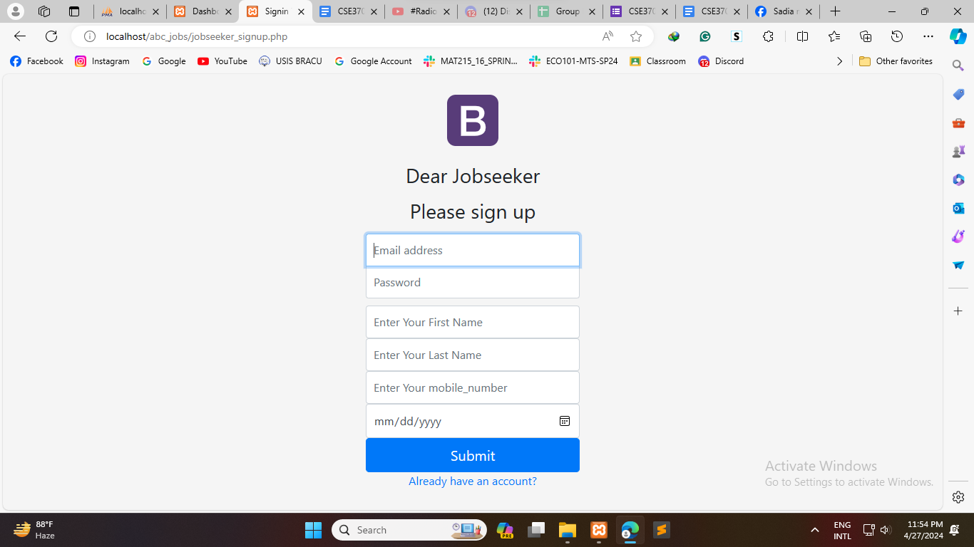
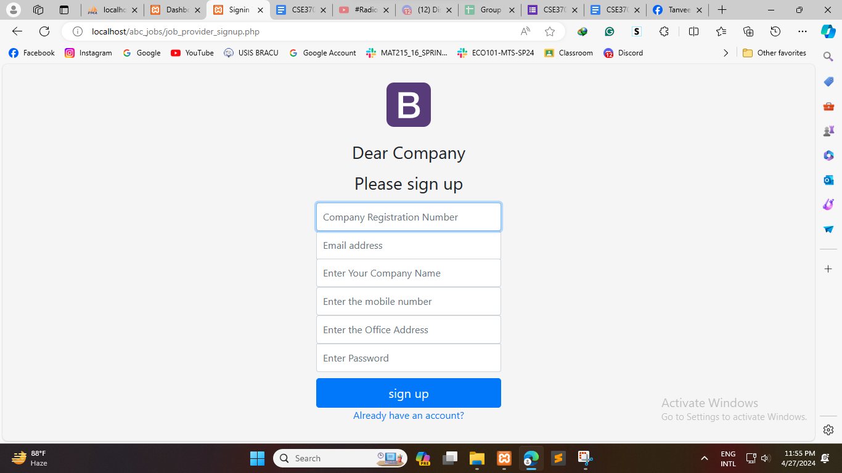
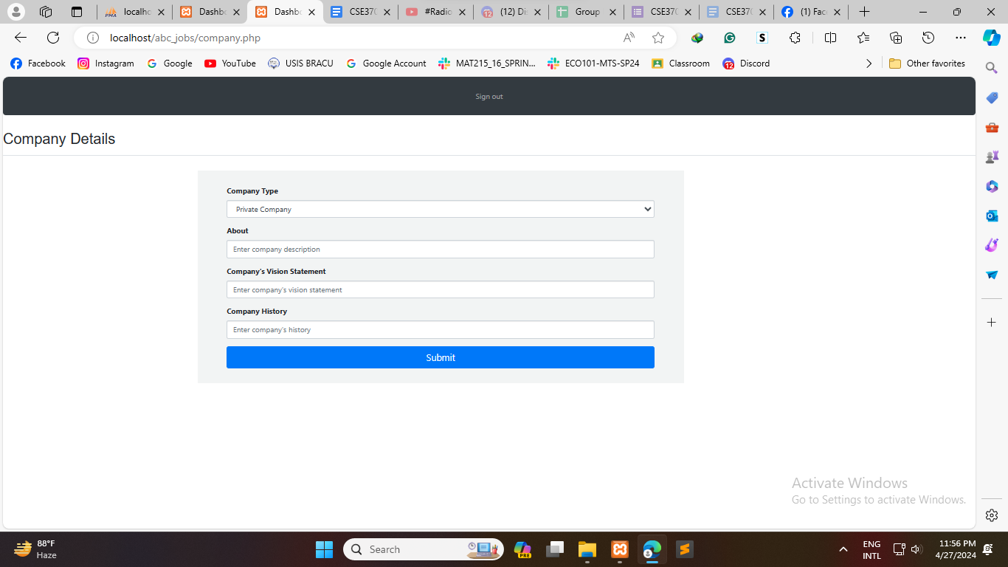
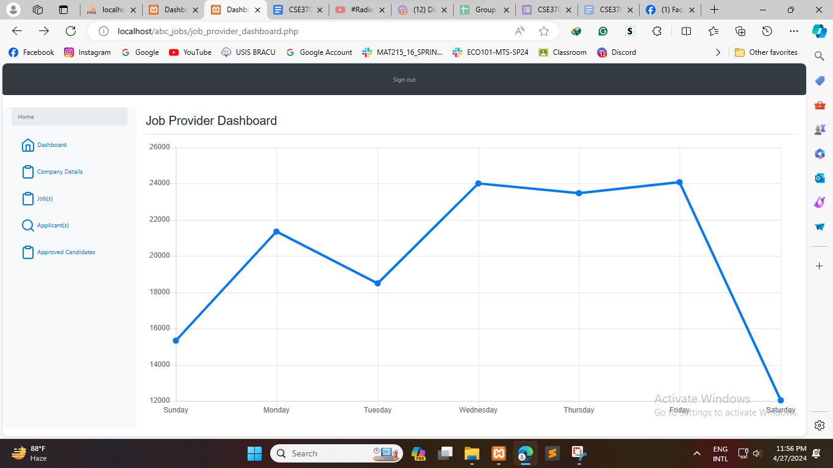
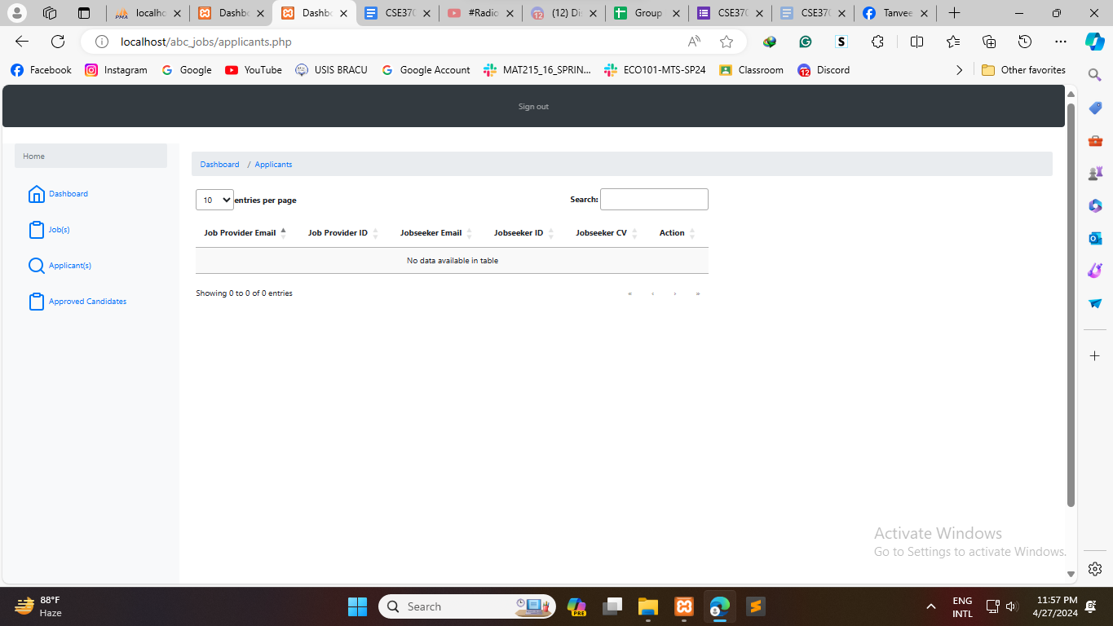
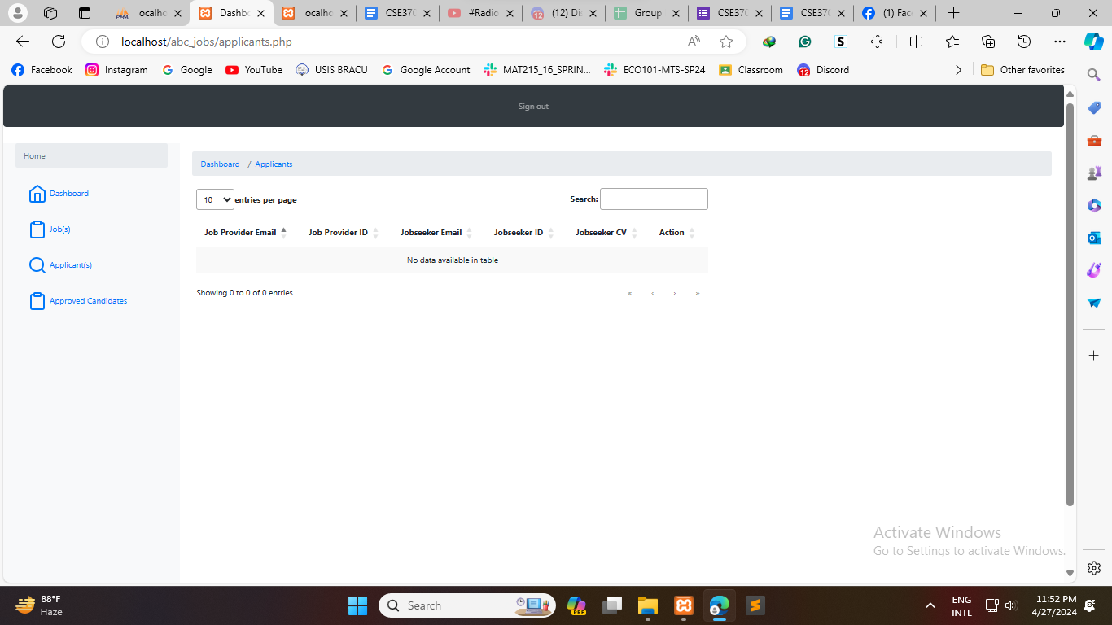
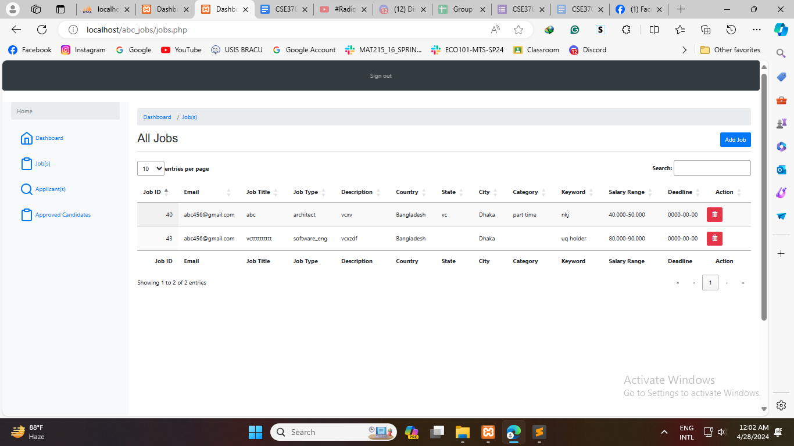

View CV and Edit CV
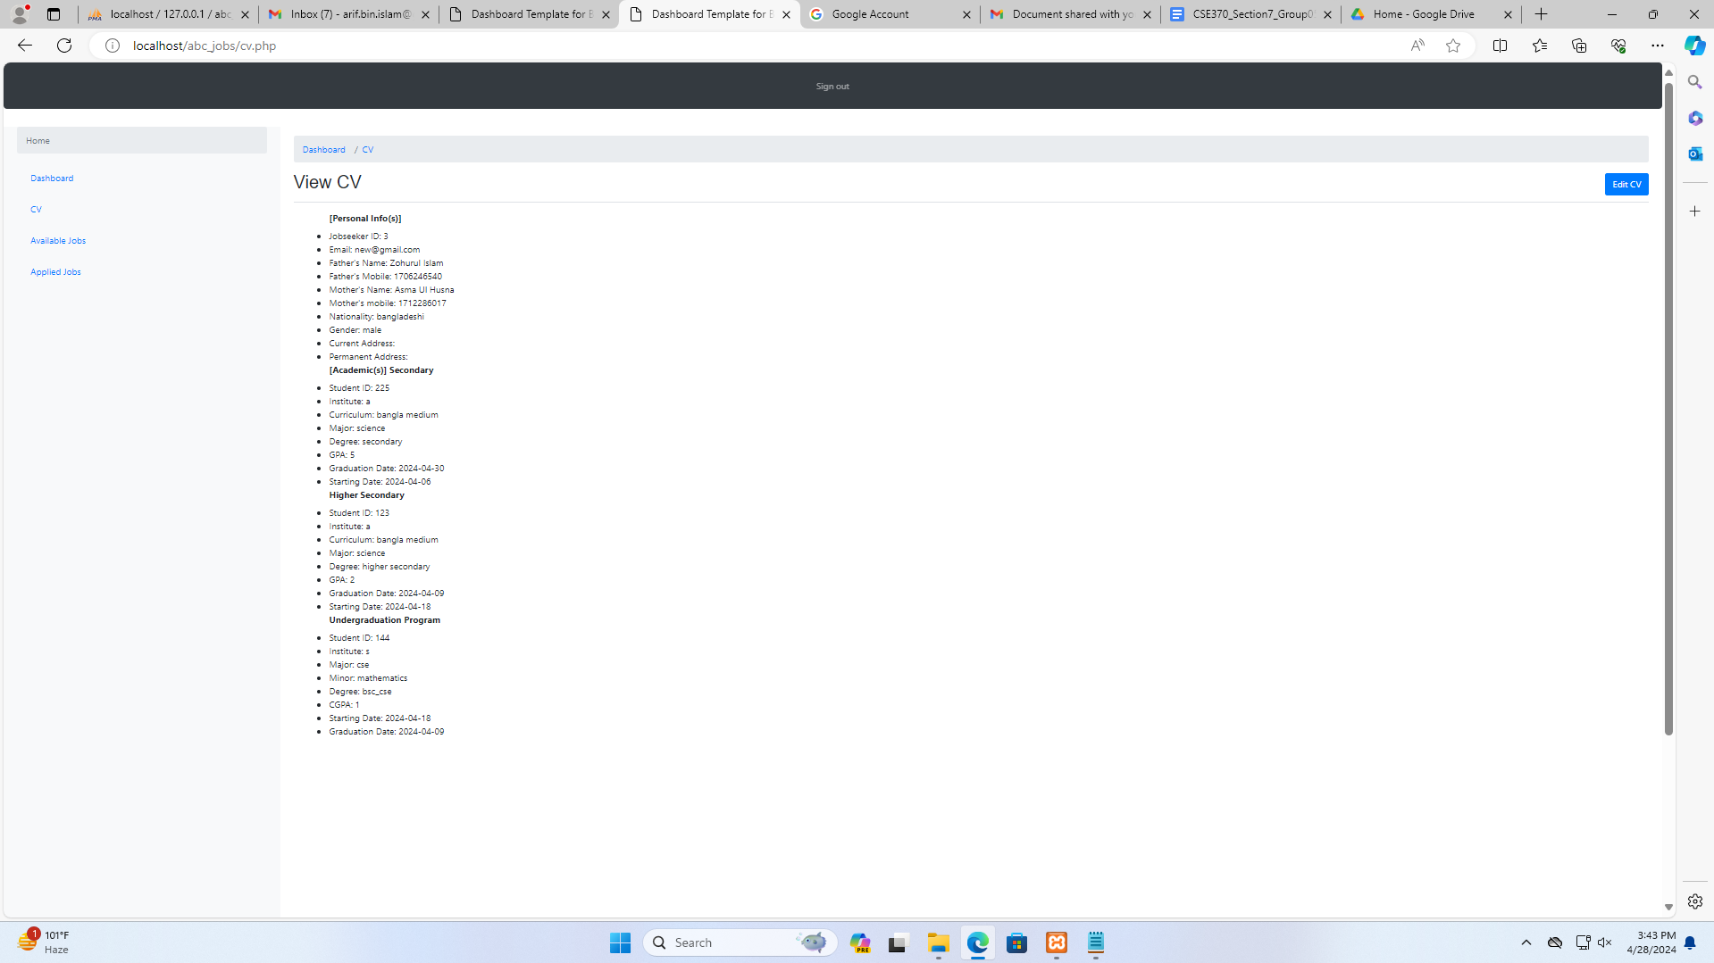
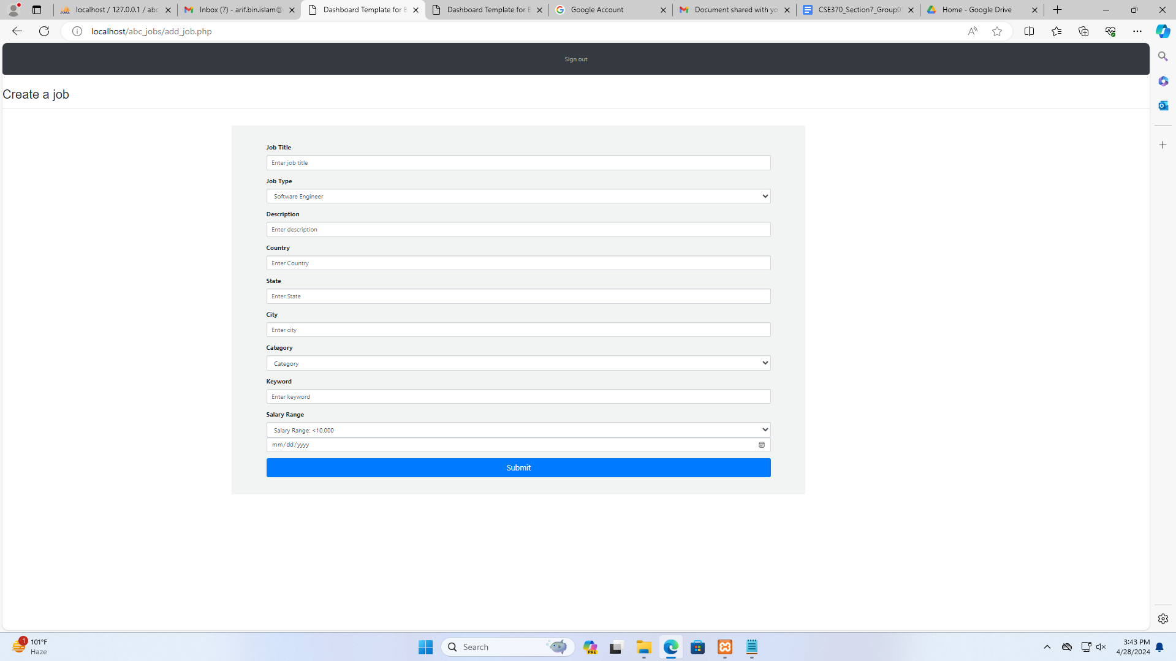
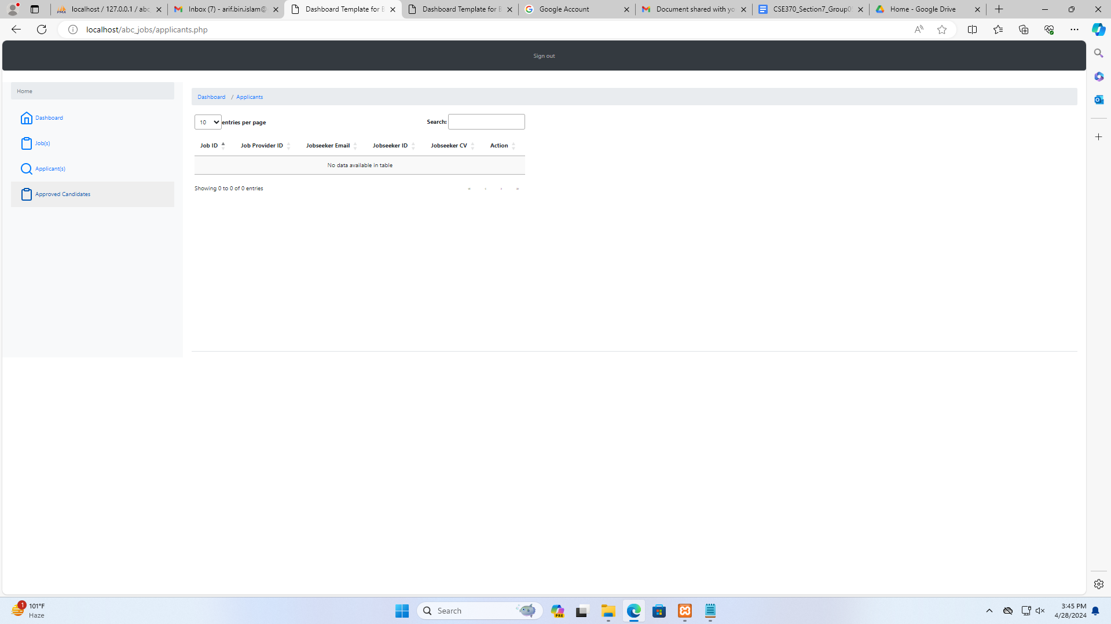
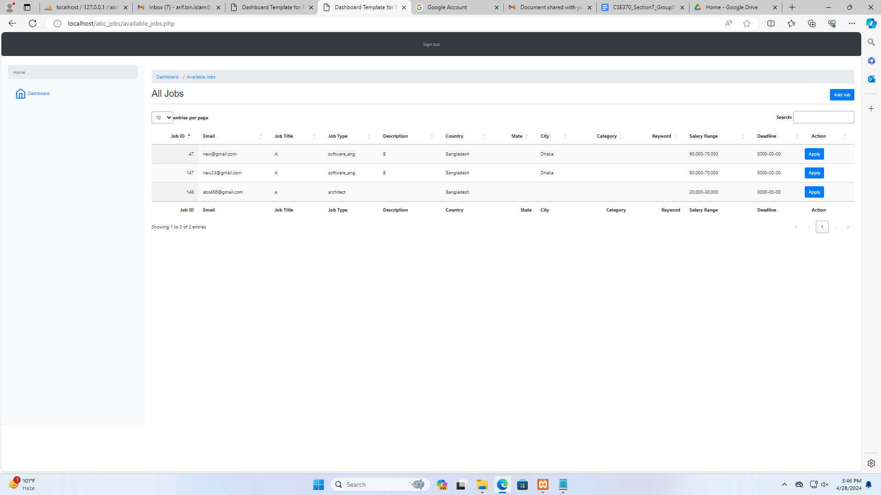

Backend Development

Briefly discuss about Backend Development and add Screenshots by mentioning Individual Contributions

Contribution of ID :21201114, Name : Tasnim Rahman
For adding all the php files with my database I used this:
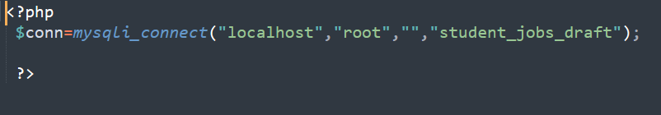
For header and sidebar I kept a separate file so that it can run fast:
Both CSS and JavaScript resources are included in the code for styling and functionality purposes.And HTML for the entire structure of the web page and PHP is used for mainly session management.
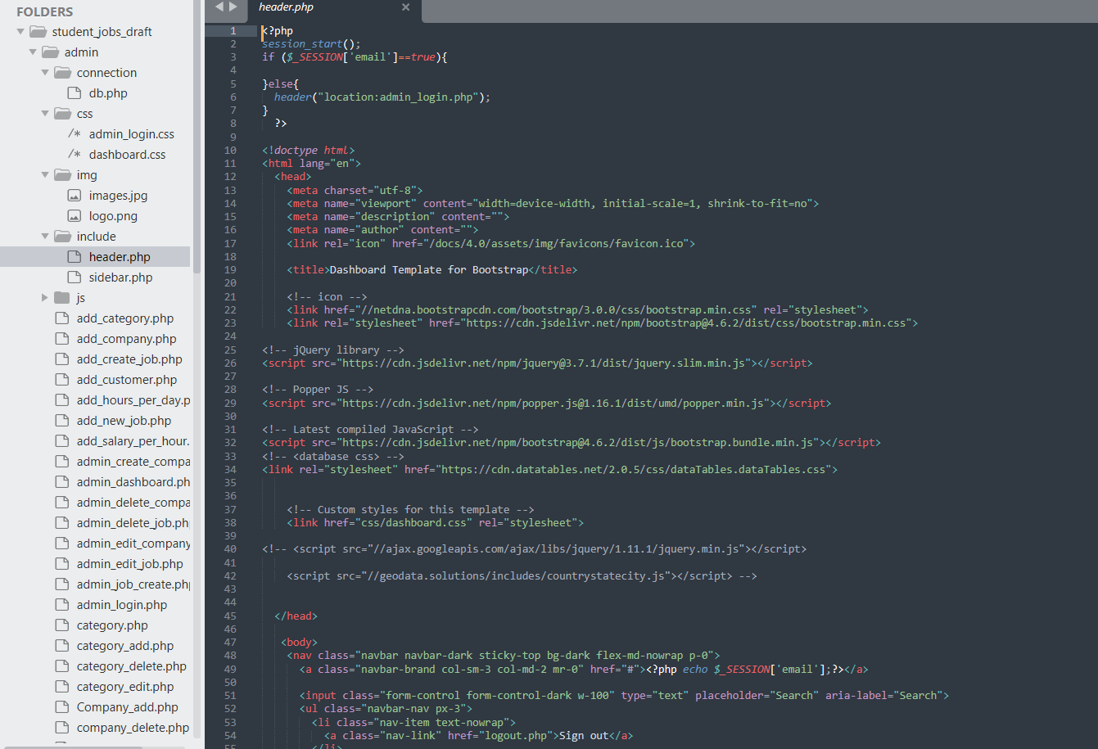
Sidebar:
PHP is used to check if a user is logged in as which kind of admin and by using the if else condition there are two kinds of dashboards.
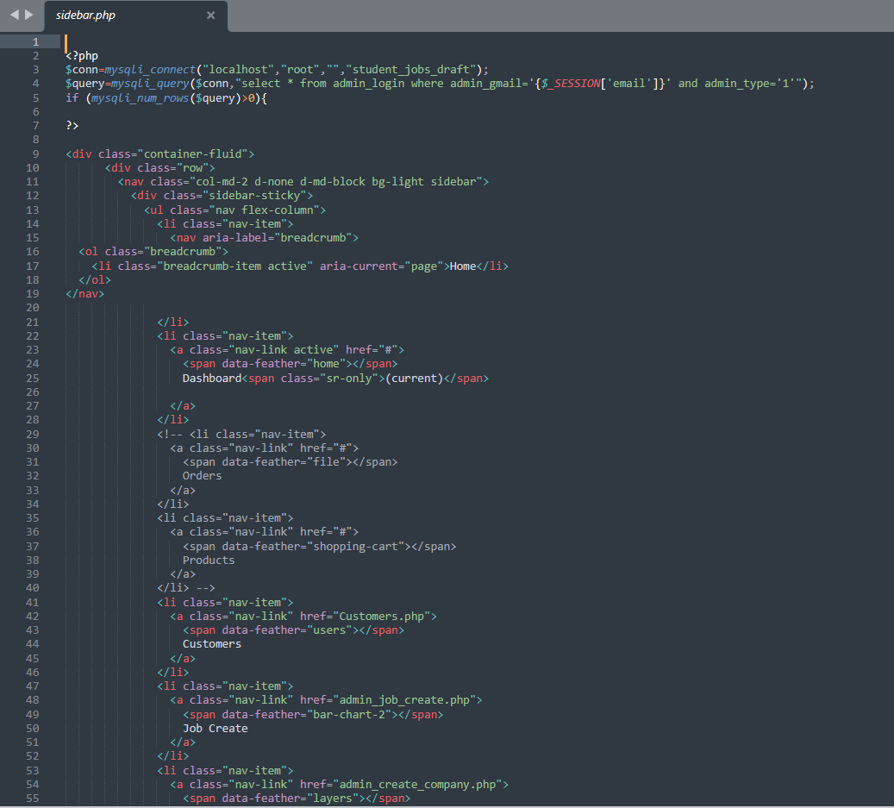
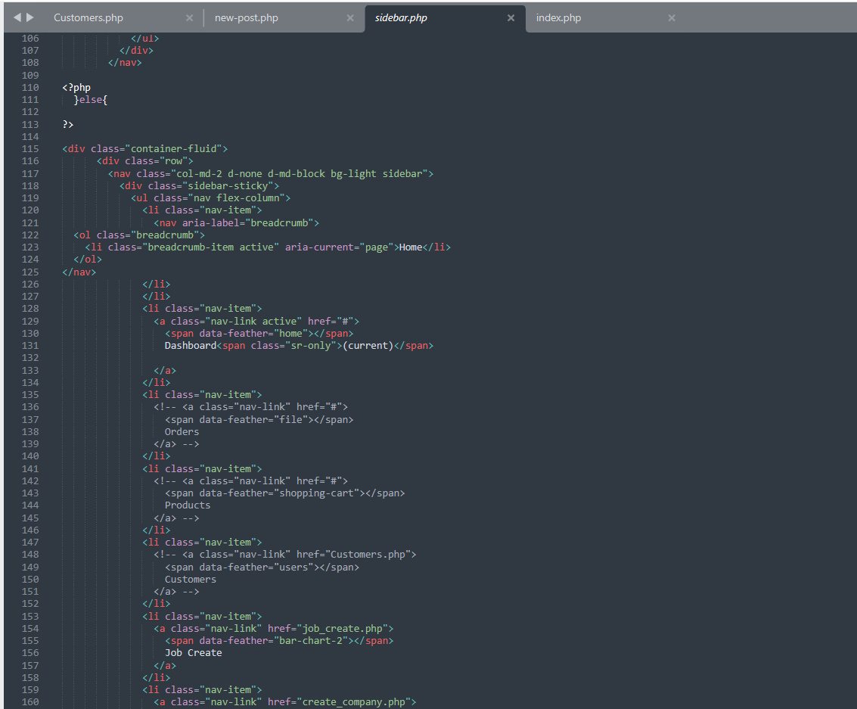
Admin login and dashboard: In login part the session is used to persist user authentication data across multiple pages, ensuring that the user remains logged in as they navigate through the website and here HTML for the login form, CSS for styling, and PHP for server-side processing to authenticate users based on their email and password, redirecting them to an admin dashboard.
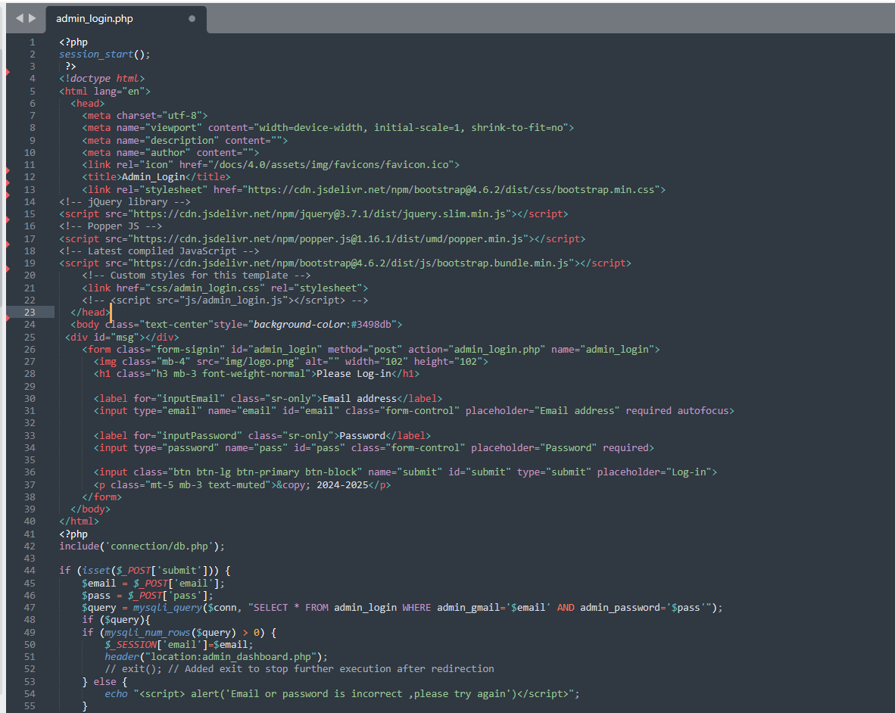
For dashboard :PHP files for header and sidebar, then displays a dashboard page with charts and tables using HTML, CSS, JavaScript (Chart.js), and Bootstrap.
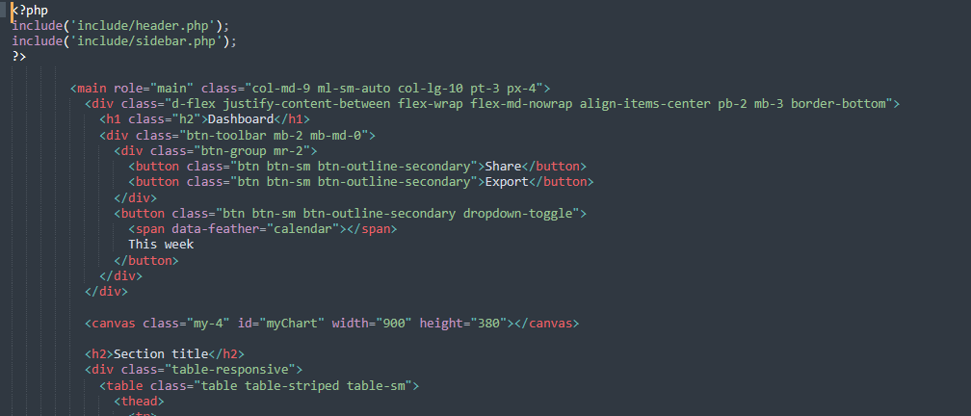

Add customer ,edit,delete by admin:
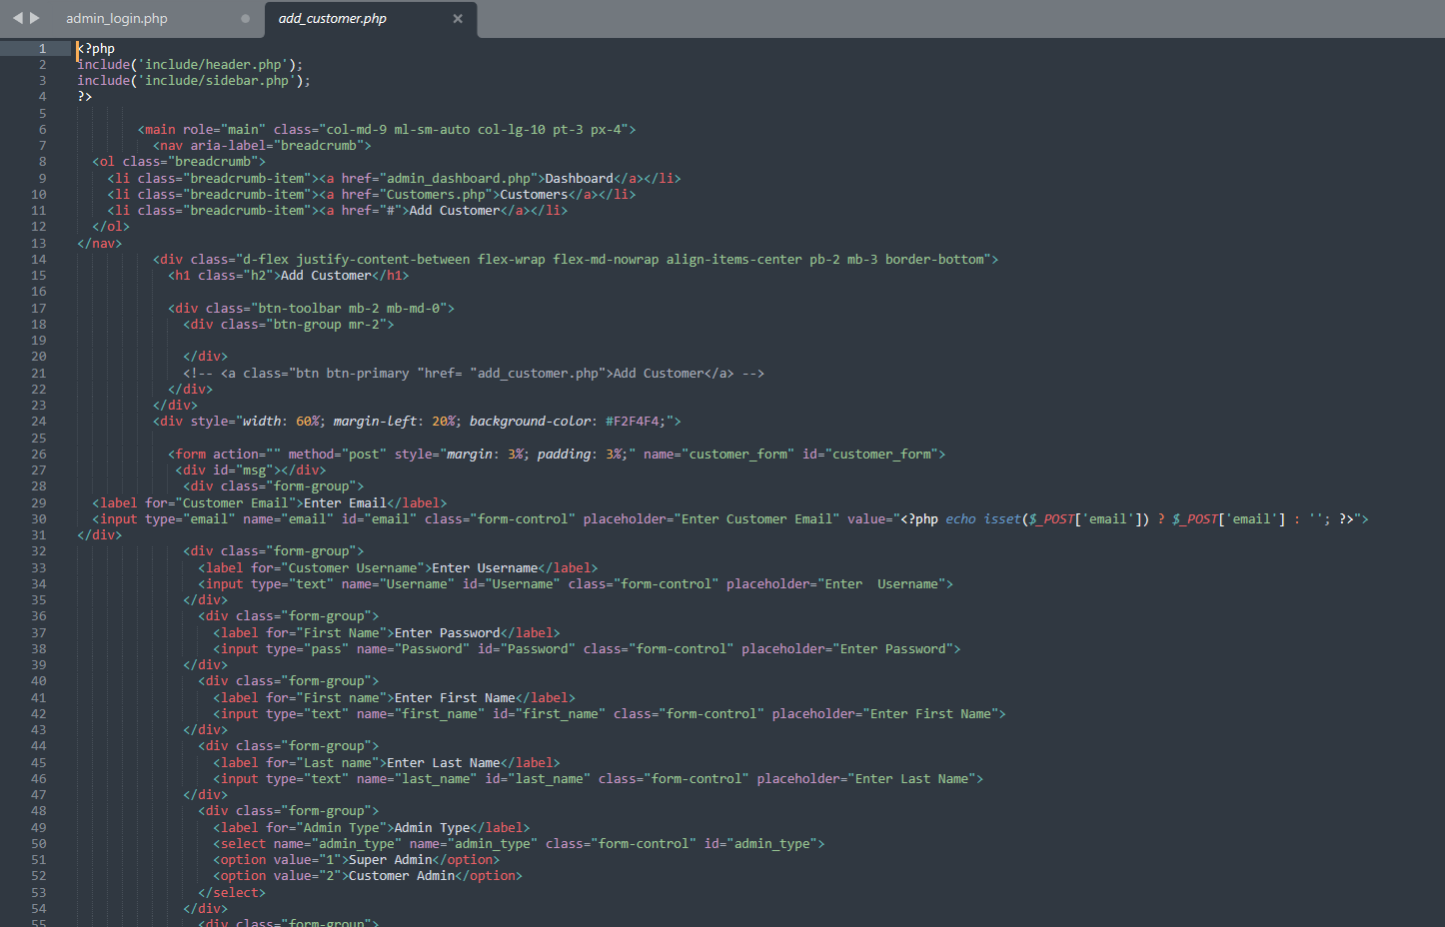
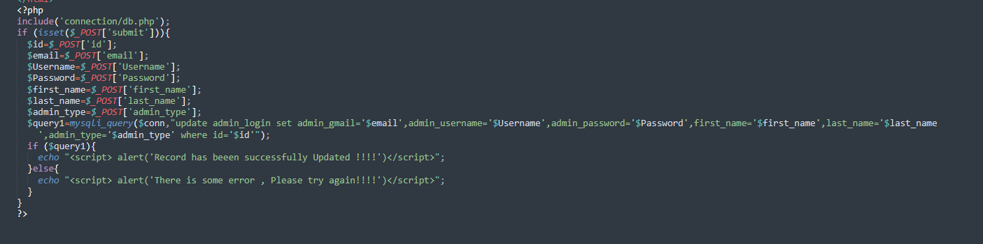
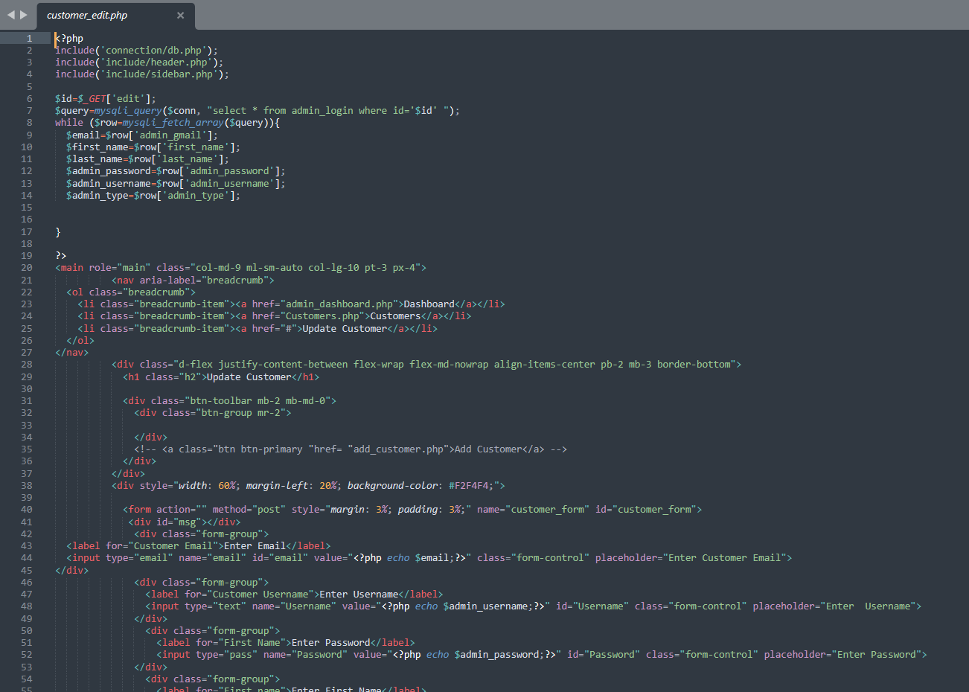
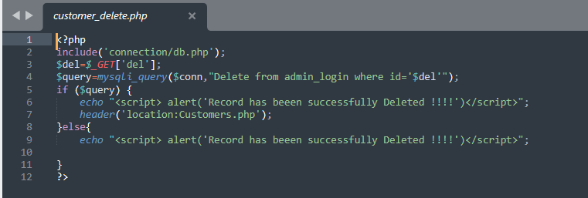

Job(edit,delete,add,create):
Here the job is fetched from the database and placed as a list by allowing the admin to view, edit, and delete job entries. Here JavaScript for table functionality like sorting, searching, and pagination in the job table, PHP for server-side processing, and SQL to query the database for job data
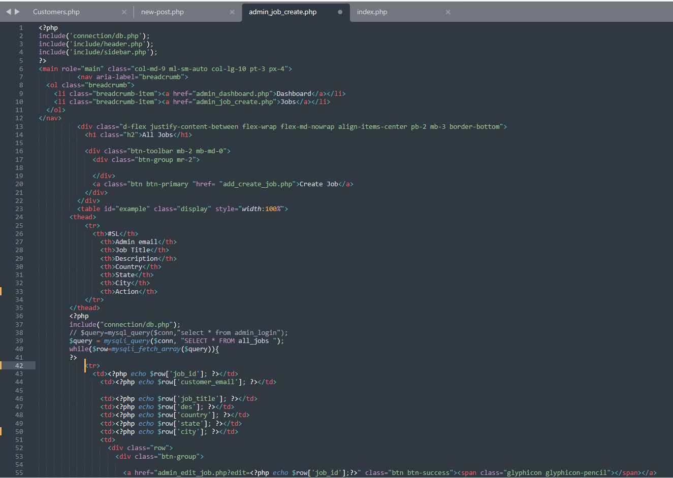
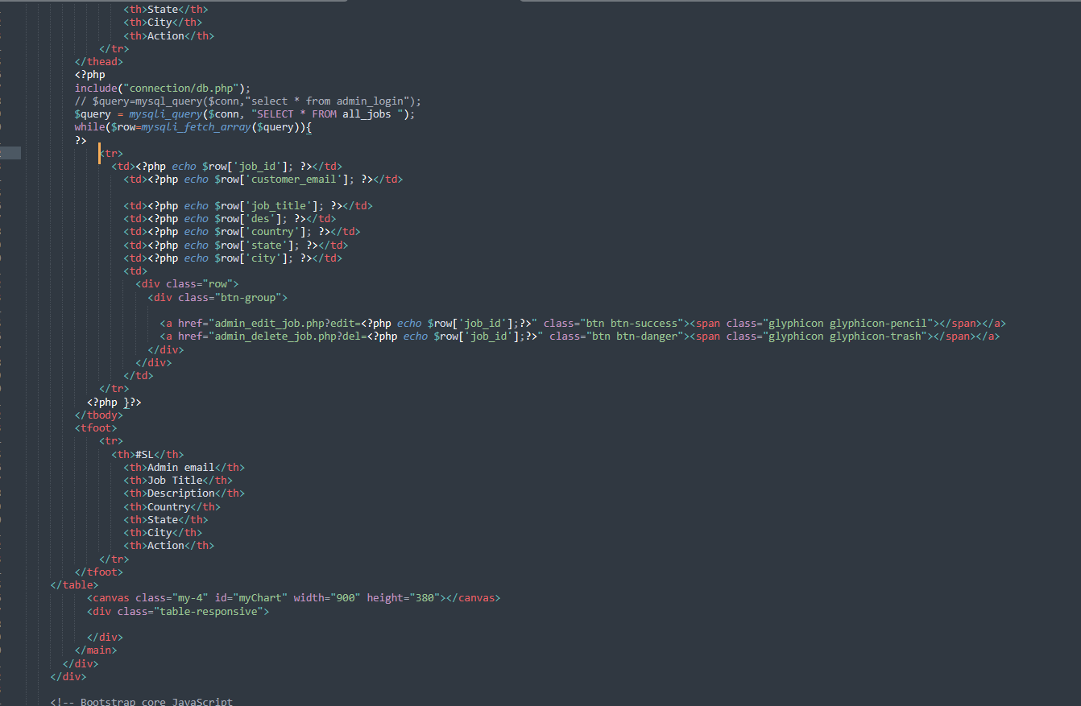
.For customer admin the thing is almost the same but to give him access of his own post session part has been used.
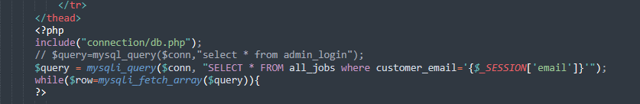

To add job HTML and JavaScript to create a form.JavaScript is used to validate form inputs and submit the form.Breadcrumbs are included for navigation.
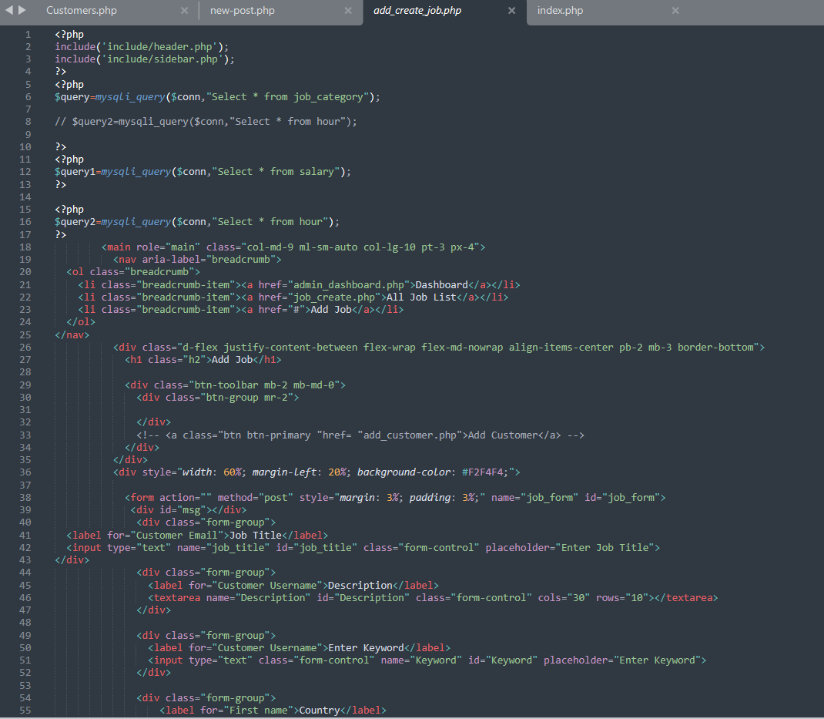
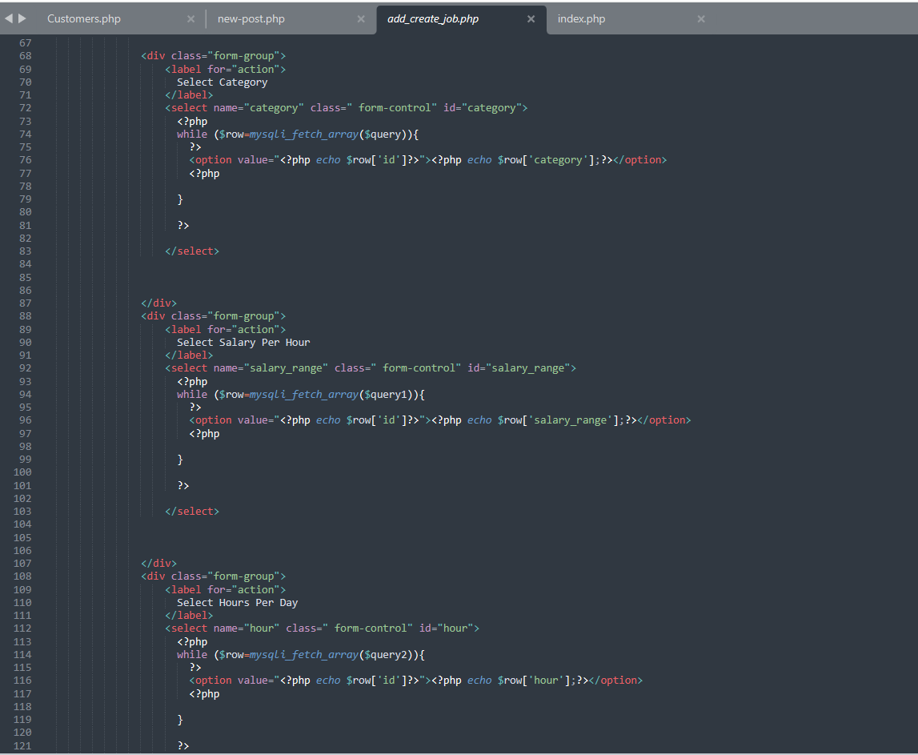
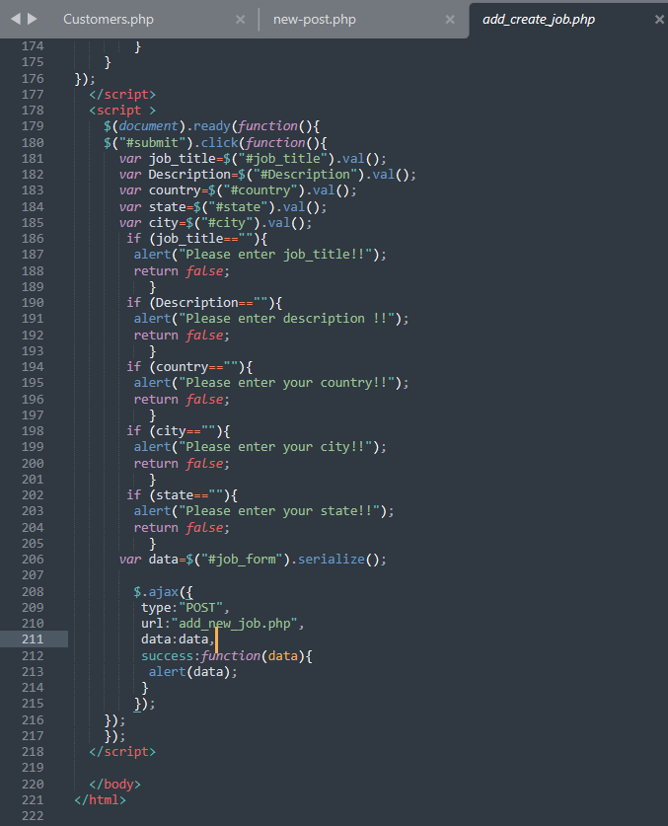
Like add job edit job is almost similar it can update the existing database.
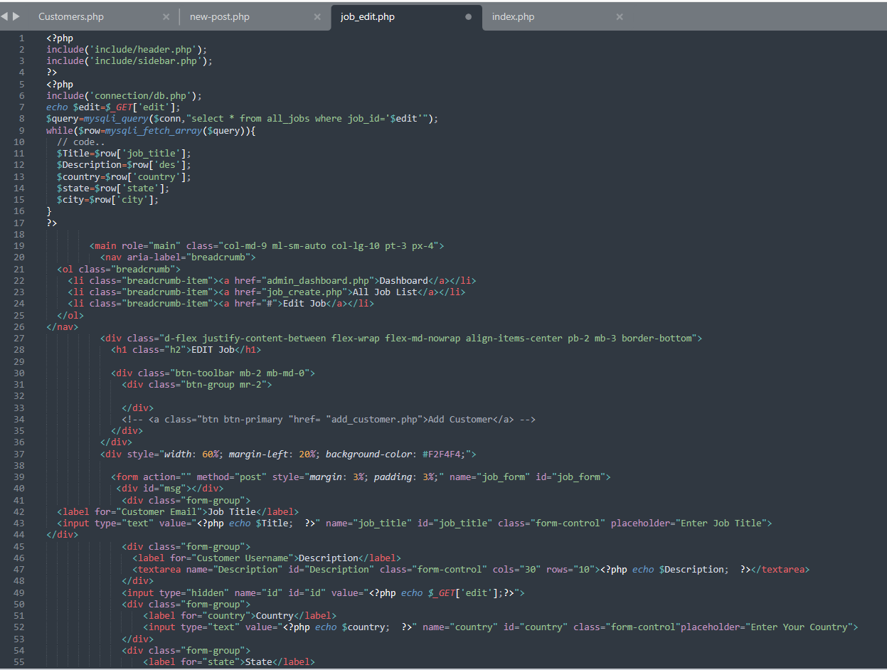
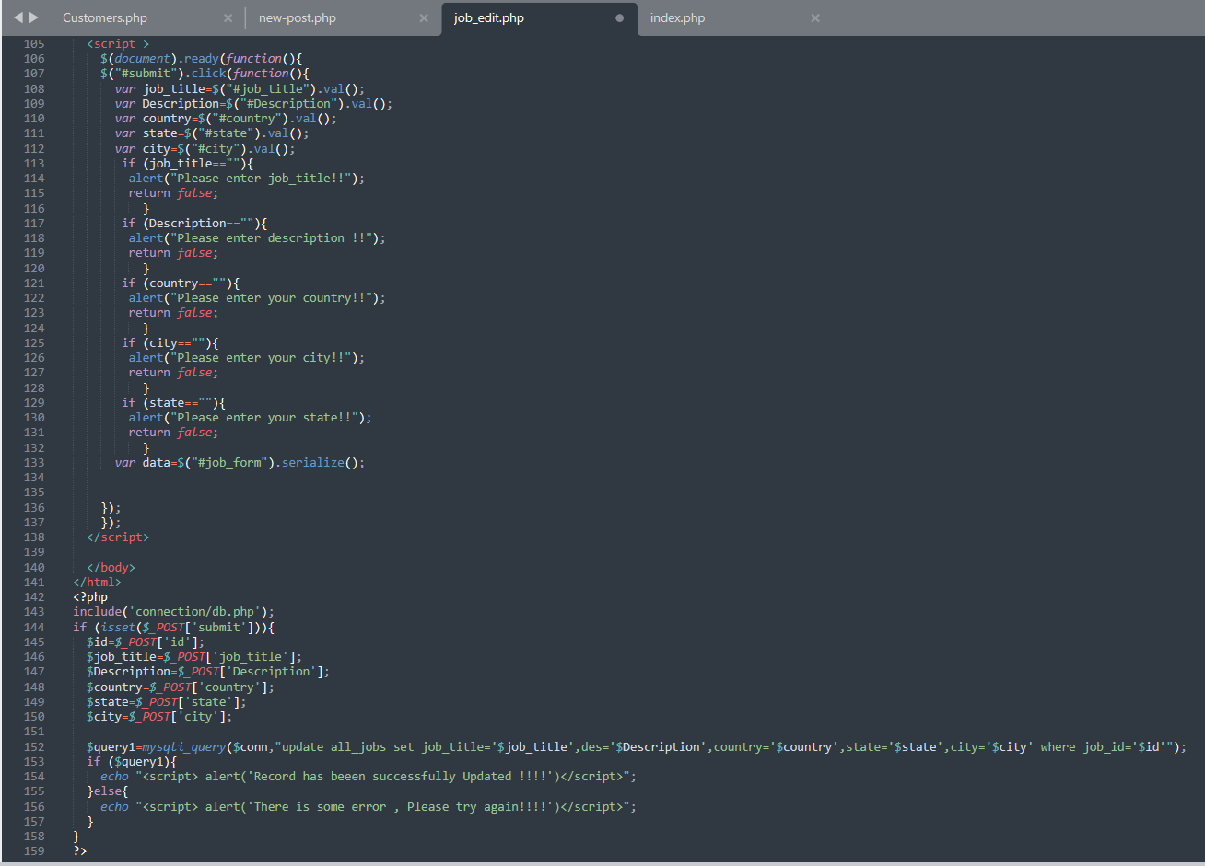
Delete:
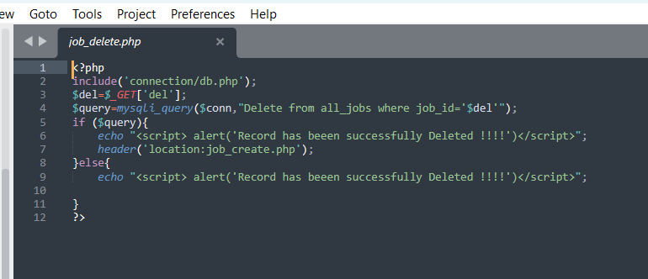
Company:
As for adding jobs the company adding part is almost the same : here also I gave an extra privilege to super admin by adding a session to the customer add part so that customer_admin can not see the whole database but its own inputs on the other hand the super admin can not post any company but can edit,delete the existing data.
Customer:
Only the super admin can add,edit customers and can control which one is super or customer admin.
Searching:
In the index file it creates a job search interface allowing users to filter job listings based on keywords, category, working hours, and salary range, utilizing MySQL database queries, HTML for structure and forms. It dynamically generates job listings based on the search criteria submitted by the user, displaying relevant job details fetched from the database.CSS and JavaScript libraries like Bootstrap, jQuery, and other custom styles/scripts are included to enhance the appearance and functionality of the web page.
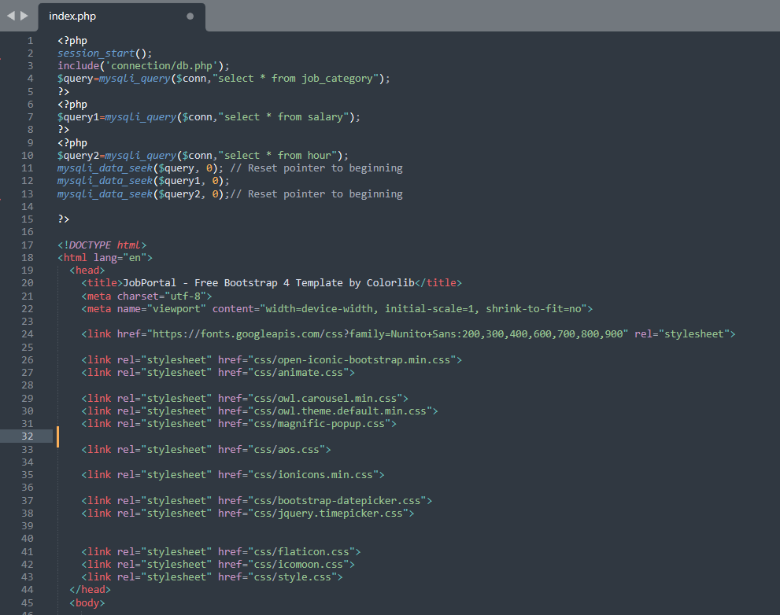
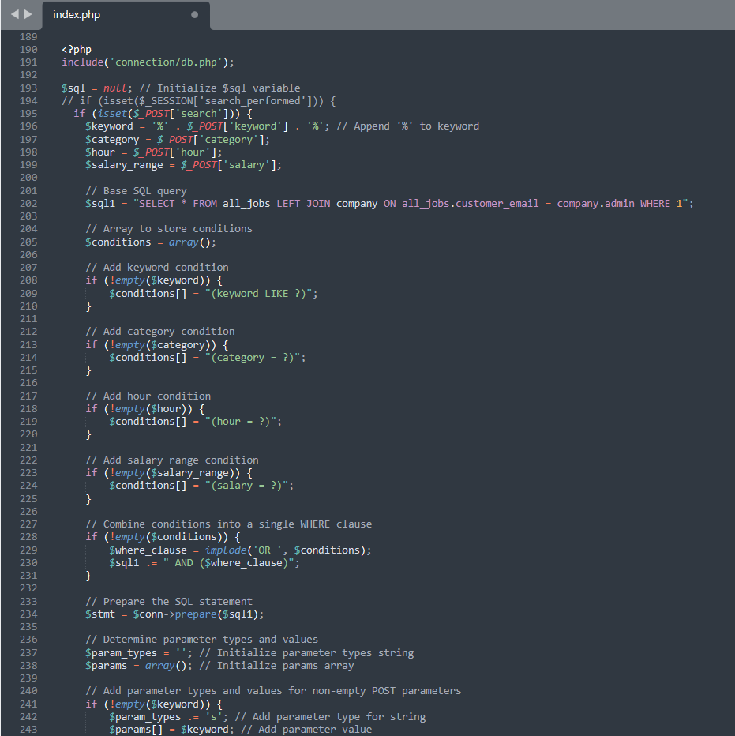
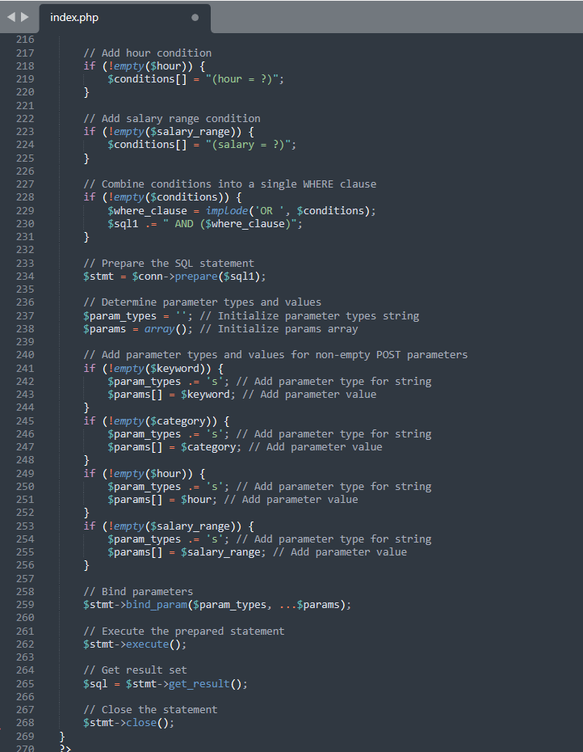
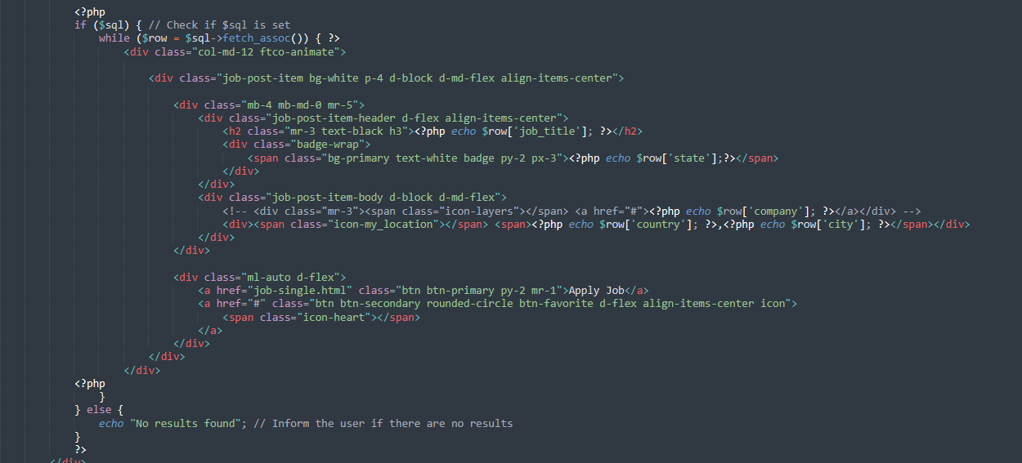
This is used to show the output form of the searched jobs.
There are some options like Keyword , category,salary_range,hour per day wise searching. Super admin can add those options as an extra privilege.The process is same like job and company part.these options can be edit,delete by the super _admin.
And also log-out option:This will take the customer admin to the login page again.
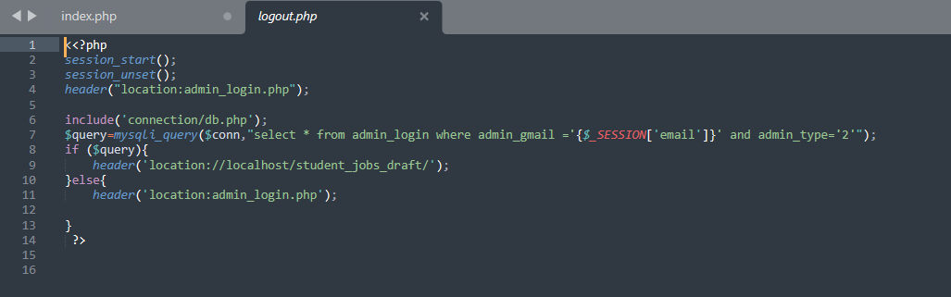

Contribution of ID :21301601, Name : Tanveer Hasan

I made the jobs.php and the header.php for all the titles and the footer.php.
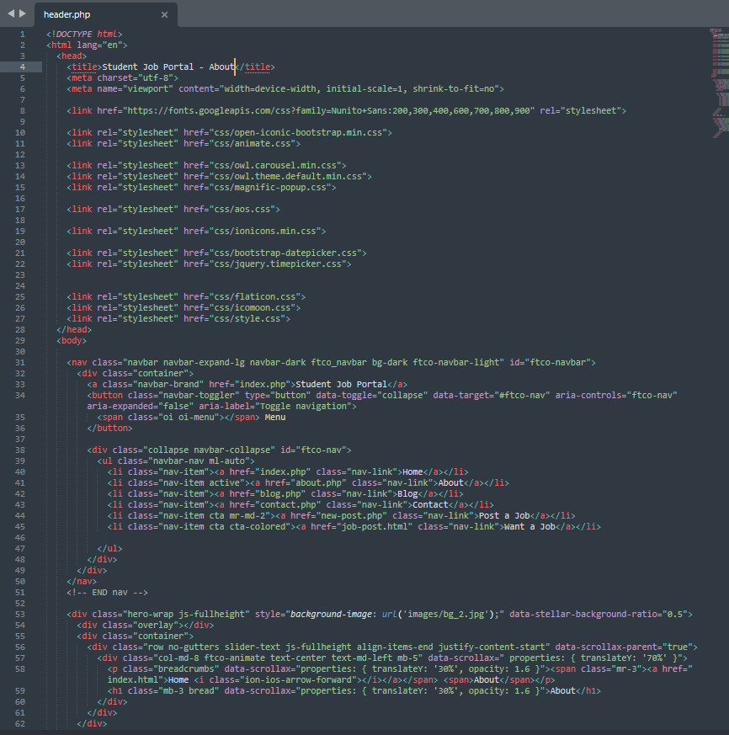
Header.php

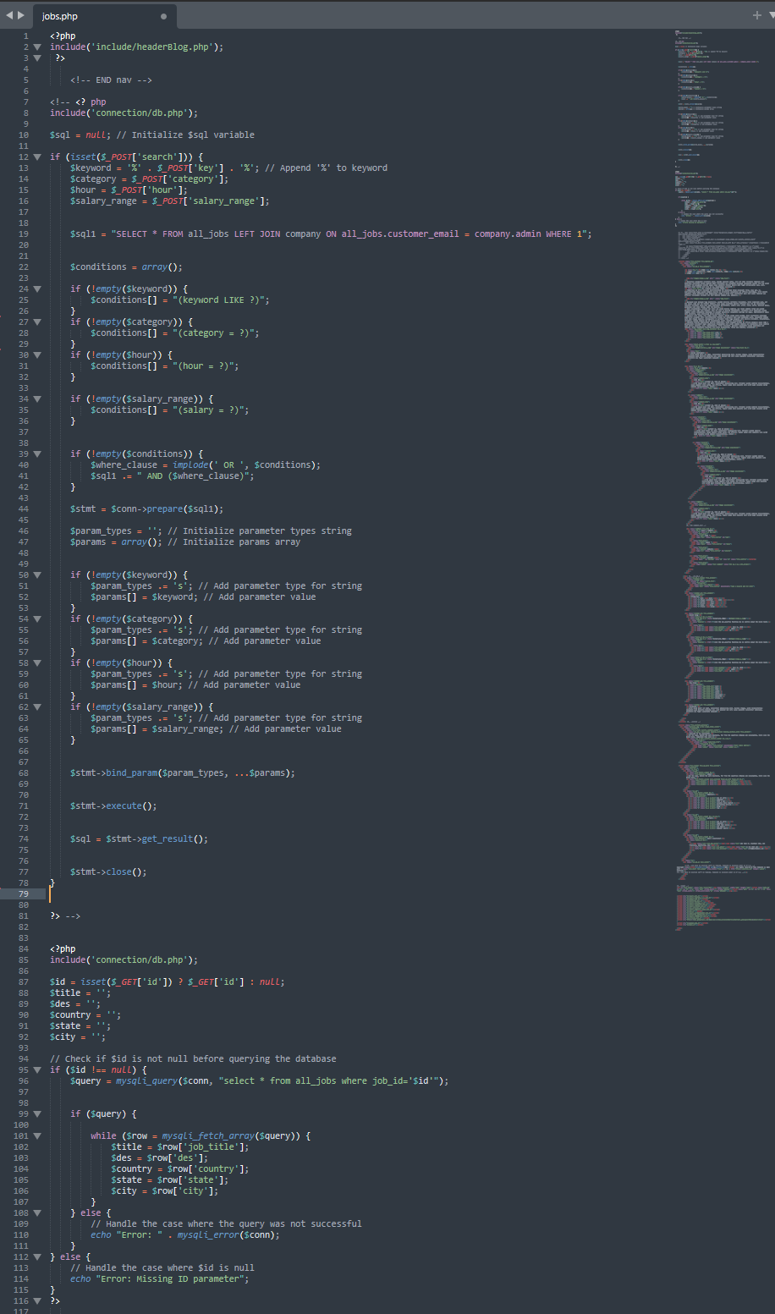
Job.php

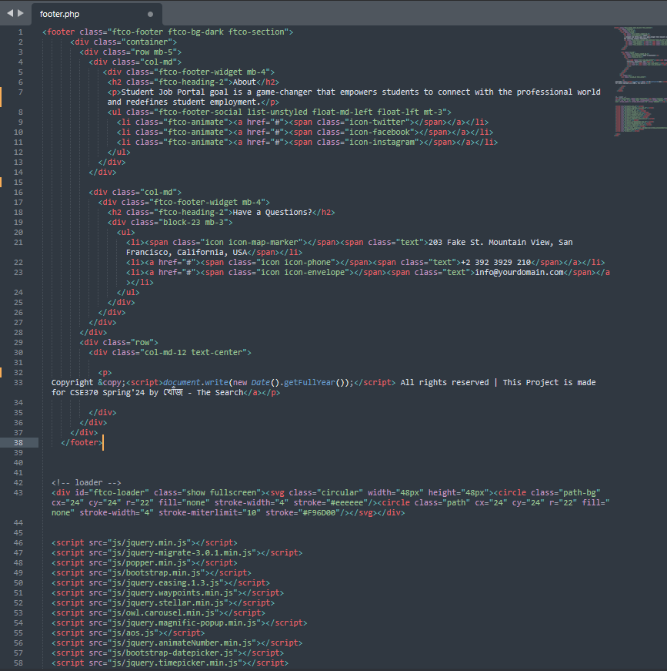
Footer.php

Contribution of ID : 22101623, Name : Arif Bin Islam

I’ve created signup page for both jobseeker and jobprovider named as job_post.php and new-post.php, that will insert data into jobseeker & jobprovider tables. Also, simultaneously created a blank cv form for jobseeker. Jobseeker_dashboard would have a cv option. In cv.php, I’ve showed the view cv & added a ‘edit cv’ button, by which jobseeker can edit his cv as wish.

Added signout and signin for both.
Added available jobs, applied jobs, applicants, approved candidates

jobseeker_signup.php
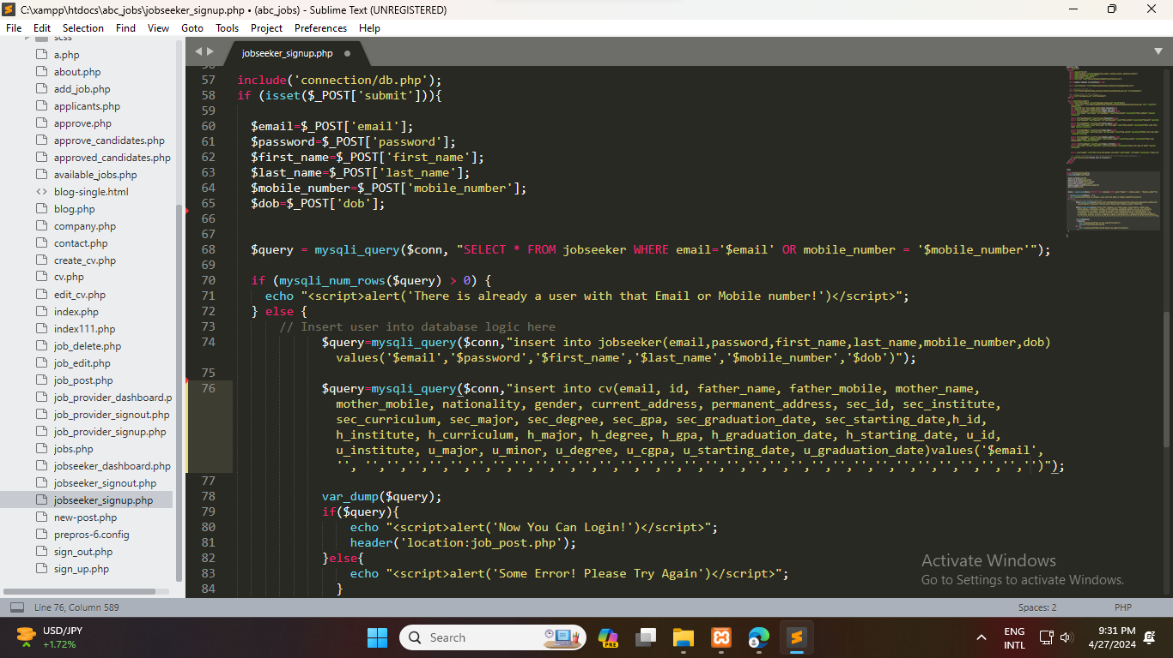
job_provider_signup.php
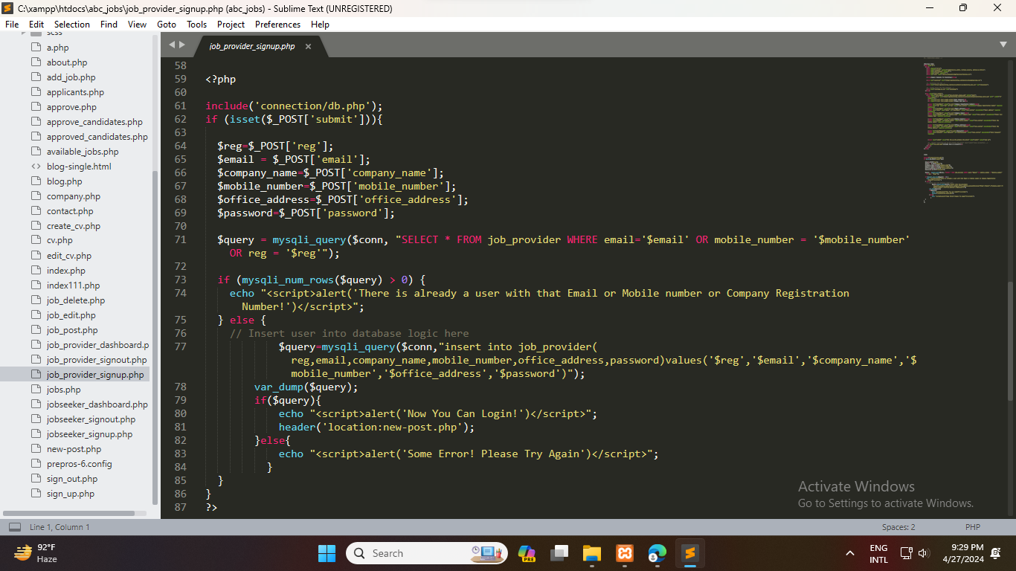
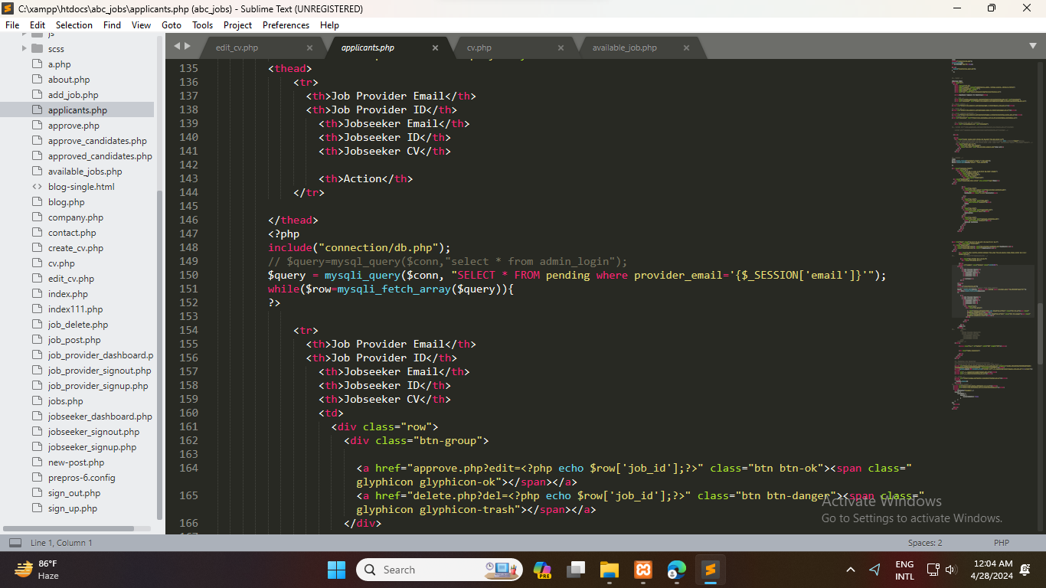
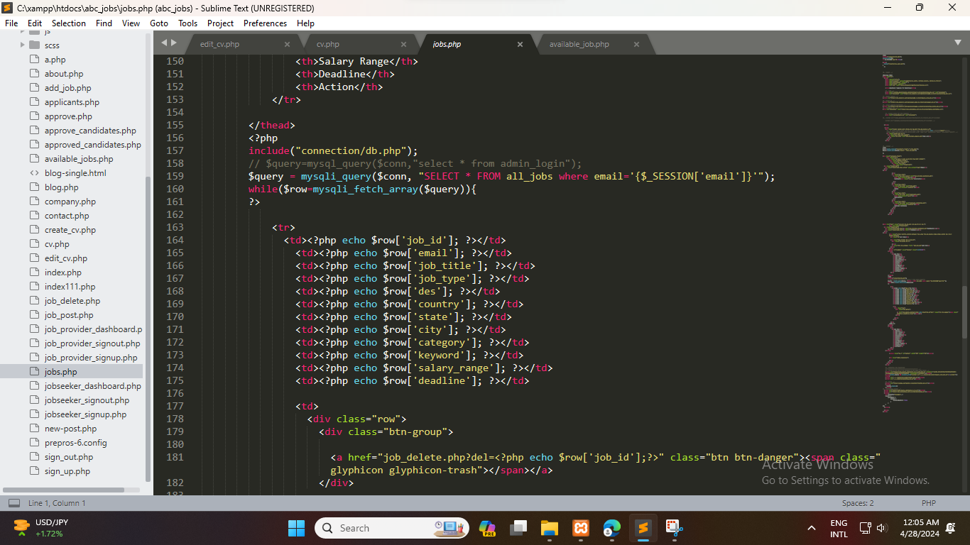
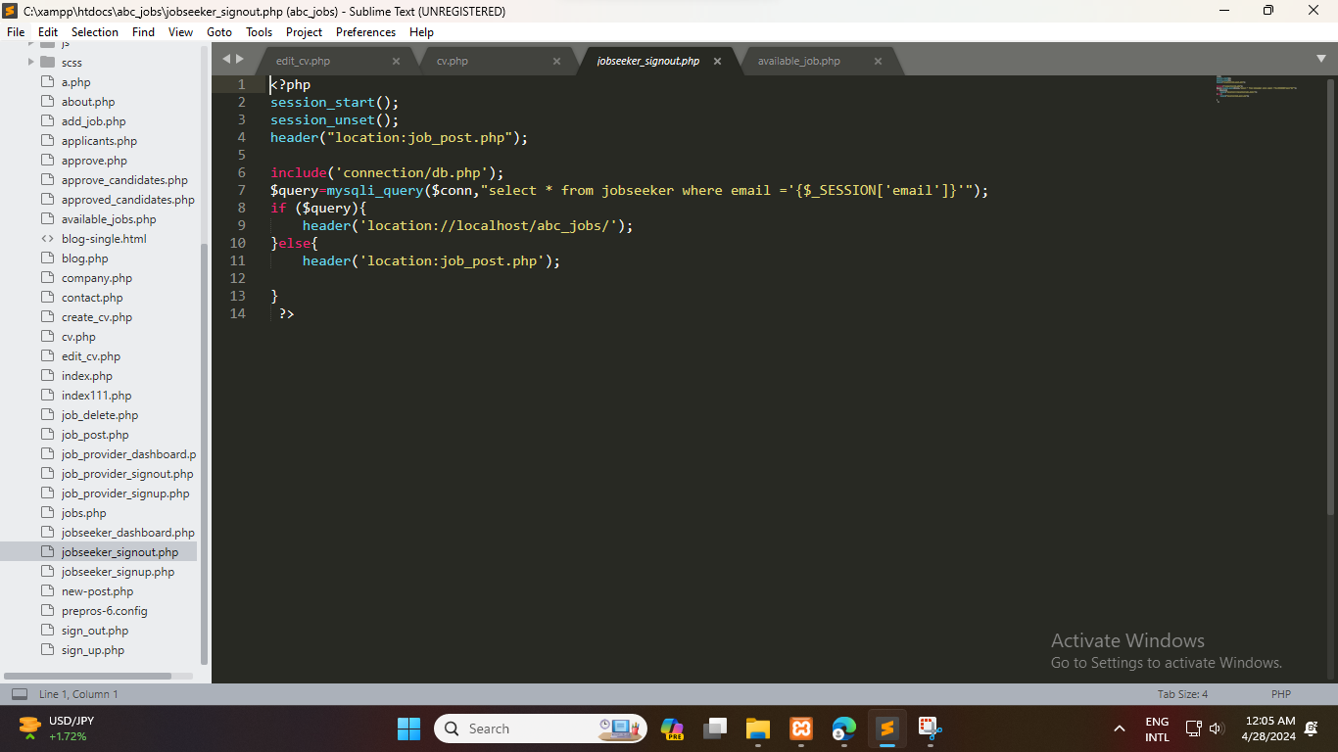
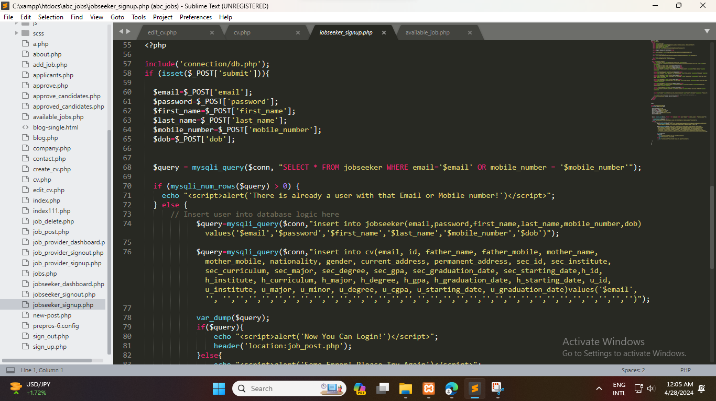
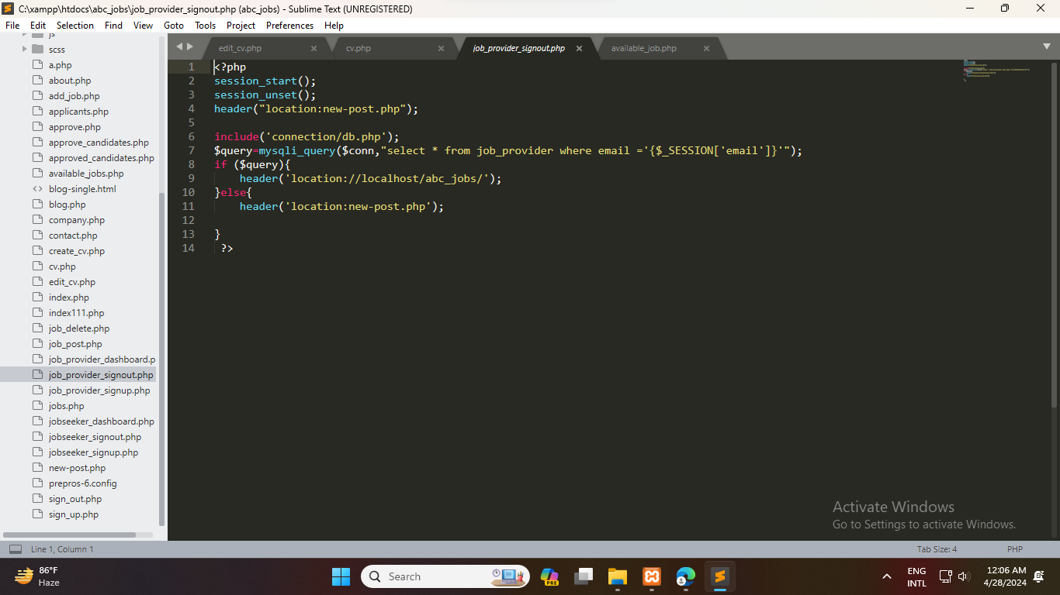
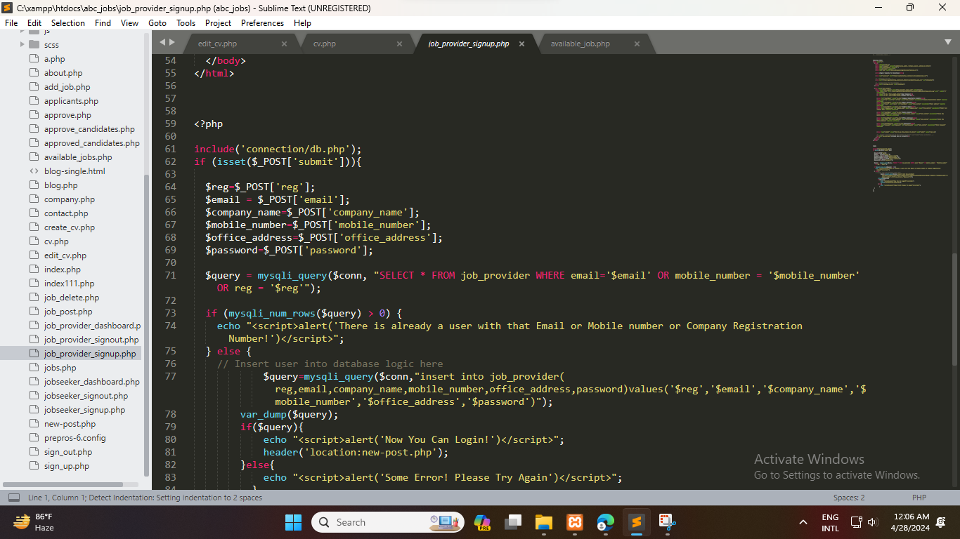
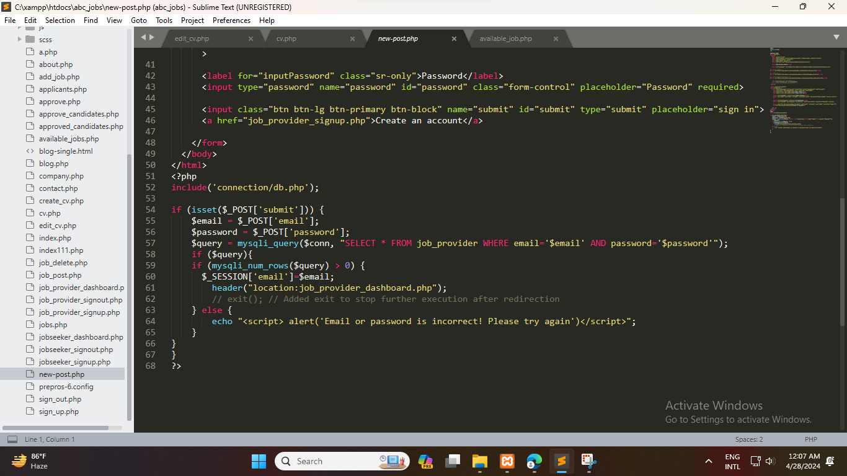
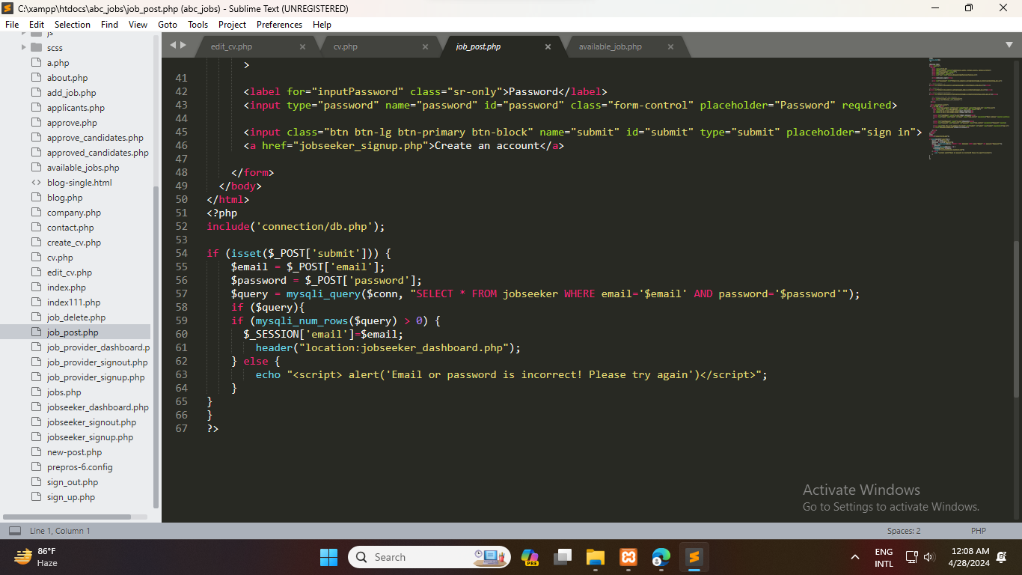
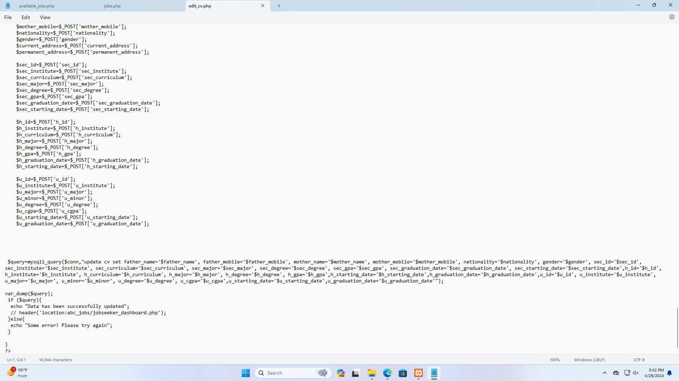
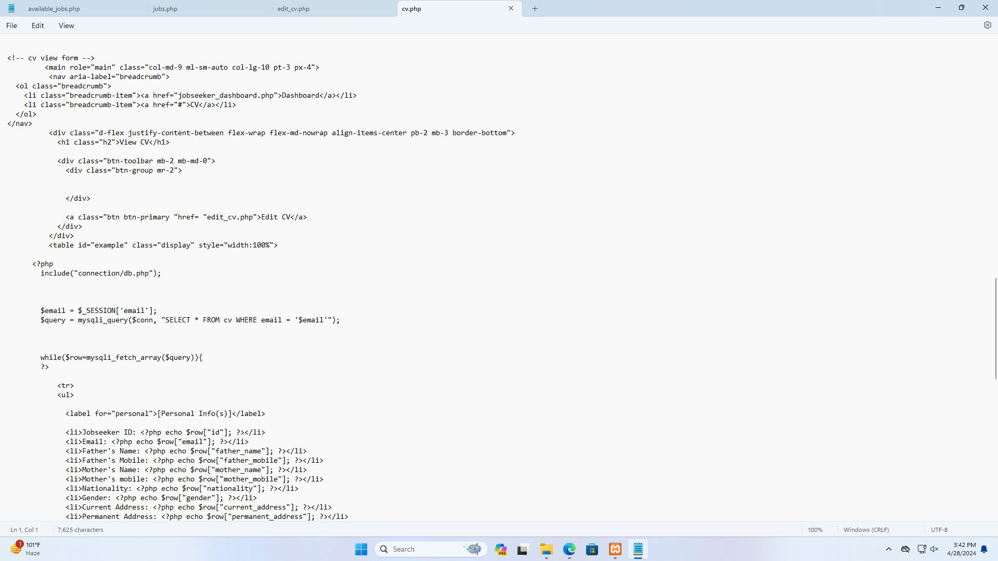

Source Code Repository

Upload source code to GitHub or Google Drive and share a publicly accessible link in this section of the report.

https://drive.google.com/drive/folders/1oFGJ92Uiln3QFDajyianENY5bOipRYu-?usp=sharing

Conclusion

To summarize, the Student Job Portal Database purportedly sets a new standard in the field of combining students and the professional world, a game changer that deviates from conventional job searching and recruitment approaches. The project was a systematic and build up of the needs through well-planned and designed, coupled with a relentless commitment to user centered principles. It resulted into a platform that fills the gap between the students who are intending to study abroad.
We see the development of the Student Job Portal Database, in terms of its impact, as the growth is not only limited to technological innovation but also goes beyond that range. Therefore, it evolves into a promise of communal activity of creating more of the environment for inclusiveness, empowerment, and competitiveness for higher education and professional courses.
The future success of the Student Job Portal Database merely is not only determined by its technology power but also through the continuous involvement and feedback of its users. As the platform goes through more rounds of iterating and refinement based data insights and consistent user demands, it won't change our determination to apply the platform innovatively and effectively as a tool for forming lasting connections, thus producing more careers of higher value.
The full-fledged Student Job Portal Database we now have shall not be seen as an end-point but as a catalyst to the ever-continuous quest for redetermining the pathway of student employment. In an inflexible way, the truth is that with the resiliency of the soul and an air of change, we, the students, are ready to be the key to a world full of opportunities where everyone can dream high and persevere against all odds eventually.

References

Kopuri, K., Mujtaba, G., Aqueel, H., Jabeen, A., Shavali, T. Tech, B & Shavali, S. (2021). A Online Job portal management system. 3.
https://www.researchgate.net/publication/348295543_A_Online_Job_portal_management_system/citation/download
Kher, S. (2016) Designing a Database for an Online Job Portal.
https://vertabelo.com/blog/designing-a-database-for-an-online-job-portal/
Colorlib. (n.d.). Job Board Archives. https://colorlib.com/wp/cat/job-board/
Bootstrap:
Contributors, M. O. J. T. a. B. (n.d.). Examples. https://getbootstrap.com/docs/4.0/examples/
Buttons:
Contributors, M. O. J. T. a. B. (n.d.-a). Buttons.
https://getbootstrap.com/docs/4.0/components/buttons/
Icons:
Bootstrap Icons. (n.d.). https://www.w3schools.com/icons/bootstrap_icons_glyphicons.asp

Bootstrap 3 Tutorial. (n.d.). https://www.w3schools.com/bootstrap/

CSS tutorial. (n.d.). https://www.w3schools.com/css/default.asp

HTML tutorial. (n.d.). https://www.w3schools.com/html/default.asp
JavaScript tutorial. (n.d.). https://www.w3schools.com/js/default.asp
SQL Tutorial. (n.d.). https://www.w3schools.com/sql/default.asp

